A Sign Of The Times Petula Clark key G Intermediate

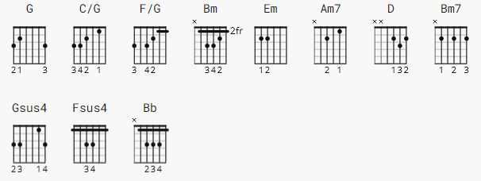

(font 10 pt. )

[Intro ]

|G C/G |F/G |G C/G |F/G |
* * * * * * * * * * * * * * * *

|G C/G |G C/G |G C/G |G C/G |
* * * * * * * * * * * * * * * *

(font 12 pt. )

[Chorus]

G Bm Em
It's a sign of the times
Am7 D Am7 D
That your love for me is getting so much stronger
G Bm Em
It's a sign of the times
Am7 D Am7 D
And I know that I won't have to wait much longer

[Verse 1]

Bm7
You've changed a lot somehow
Am7
From the one I used to know
Bm7
For when you hold me now
Am7 D
I feel like you never want to let me go

[Chorus]

G Bm Em
It's a sign of the times
Am7 D Am7 D
That you call me up whenever you feel lonely
G Bm Em
It's a sign of the times
Am7 D Am7 D
That you tell your friends that I'm your one and only
[Verse 2]

Bm7
I'll never understand
Am7
The way you treated me
Bm7
But when I hold your hand
Am7 D
I know you couldn't be the way you used to be

[Bridge]

Gsus4
Maybe my lucky star
G
At last decided to shine
Fsus4
Maybe somebody knows
Bb Am7 D Am7 D
How long I've waited to make you mine Mm mm mm

[Brass]

|G |Bm Em |Am7 D |Am7 D |
* * * * * * * * * * * * * * * *

|G |Bm Em |Am7 D |Am7 D |
* * * * * * * * * * * * * * * *

[Verse 3]

Bm7
I'll never understand
Am7
The way you treated me
Bm7
But when I hold your hand
Am7 D
I know you couldn't be the way you used to be

[Bridge]

Gsus4
Maybe my lucky star
G
At last decided to shine
Fsus4
Maybe somebody knows
Bb Am7 D Am7 D
How long I've waited to make you mine
[Chorus]

G Bm Em
It's a sign of the times
Am7 D Am7 D
That you kiss me now as if you really mean it
G Bm Em
It's a sign of the times
Am7 D Am7 D
And a year ag o I never could have seen it

[Verse 4]

Bm7
Don't ever change your mind
Am7
And take your love away
Bm7
Just leave the past behind
Am7 D
And, baby, only think of how it is today

[Coda]

G C/G
It's a sign of the times
G C/G
It's a sign of the times
G C/G
It's a sign of the times
G C/G
It's a sign of the times
G C/G
It's a sign of the times

