A Sign Of The Times Petula Clark key Bb Intermediate

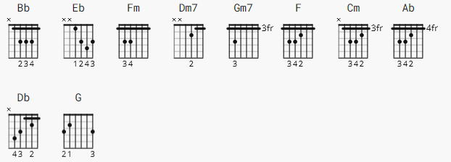

INTRO: Bb Eb Fm Eb Bb..Eb Fm Eb Bb Eb

#1.

Bb Dm7 Gm7
It's a sign of the times, that your love for
F Cm F
me is getting so much stronger.
Bb Dm7 Gm7 Cm F
It's a sign of the times, and I know that I won't
Cm F
have to wait much longer.

CHORUS:

F Cm
You've changed a lot somehow from the one I used
F
to know-oh-oh.
Dm7 Cm
For when you hold me now, you feel like you never
F
wanna to let me go.

#2.

Bb Dm7 Gm7 Cm F
It's a sign of the times, that you call me up whenever
Cm F
you feel lonely.
Bb Dm7 Gm7 F
It's a sign of the times, that you tell your friends
Cm Dm7
that I'm your one and only.

CHORUS:

Dm7 F Cm
I'll never understand the way you treated me-ee-ee.
F Cm
But when I hold your hand I know you couldn't be
F
the way you used to be.

BRIDGE:

Bb Fm Bb Cm Bb F
Maybe my lucky star at last decided to shine.
Eb Ab Eb Db Cm
Maybe somebody knows how long I've waited to make you
F Bb
mine, mm-mm.

INTERLUDE: F Dm7 Gm7 Cm F Cm F Bb Dm7 G Cm F Cm F

CHORUS:

Dm7 F Cm
I'll never understand the way you treated me-ee-ee.
F Cm
But when I hold your hand I know you couldn't be
F
the way you used to be.

BRIDGE:

Bb Fm Bb Cm Bb F
Maybe my lucky star at last decided to shine.
Eb Ab Eb Db Cm
Maybe somebody knows how long I've waited to make you
F
mine.

#3.

Bb Dm7 Gm7 Cm F
It's a sign of the times, that you kiss me now as if
Cm F
you really mean it.
Bb Dm7 Gm7 F
It's a sign of the times, and a year ago I never
Cm F
could have seen it.

CHORUS:

Dm7 F Cm
Don't ever change your mind and take your love
F
away-ay-ay.
Dm7 F Cm
Just leave the past behind and, baby, only think
F
of how it is today.

OUTRO:

Bb F Bb
It's a sign of the ti-imes..it's a sign of the
F
ti-i-i-i-imes..(x2)(Fade.)

