A Whiter Shade Of Pale Procol Harum

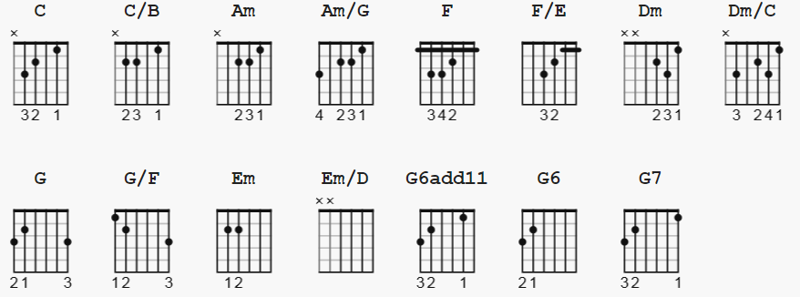
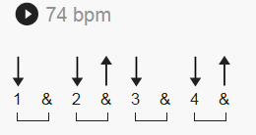

C x32010
C/B x22010
Am x02210
Am/G 302210
F xx3211
F/E xx2211
Dm xx0231
Dm/C x30231
G 320003
G/F 120003
Em 022000
Em/D xx0000
G6add11 320010
G6 320000

[Intro]

C C/B Am Am/G F F/E Dm Dm/C G G/F Em Em/D C F G F G

[Verse]

C C/B Am Am/G
We skipped the light fandango
F F/E Dm Dm/C
turned cartwheels 'cross the floor
G G/F Em Em/D
I was feeling kinda seasick
C C/B Am Am/G
but the crowd called out for more
F F/E Dm Dm/C
The room was humming harder
G G/F Em Em/D
as the ceiling flew away
C C/B Am Am/G
When we called out for another drink
F F/E Dm
the waiter brought a tray

[Chorus]

G7 C C/B Am Am/G
And so it was,___ that later,____
F F/E Dm Dm/C
as the miller told his tale
G G/F Em Em/D
that her face, at first just ghostly,
C F C G6add11 G6
turned a whiter shade of pale

C C/B Am Am/G F F/E Dm Dm/C G G/F Em Em/D C F G F G

[Verse 2]

C C/B Am Am/G
She said there is no reason
F F/E Dm Dm/C
And the truth is plain to see
G G/F Em Em/D
But I wandered through my playing cards
C C/B Am Am/G
Would not let her be
F F/E Dm Dm/C
One of sixteen vestal virgins
G G/F Em Em/D
Who were leaving for the coast
C C/B Am Am/G
And although my eyes were o____pen
F F/E Dm
They might just as well been closed

[Chorus]

G7 C C/B Am Am/G
And so it was,___ that later,____
F F/E Dm Dm/C
as the miller told his tale
G G/F Em Em/D
that her face, at first just ghostly,
C F C G6add11 G6
turned a whiter shade of pale

C C/B Am Am/G F F/E Dm Dm/C G G/F Em Em/D C F G

G7 C C/B Am Am/G
And so it was,___ that later,____
F F/E Dm Dm/C
as the miller told his tale

