Ain't No Sunshine Bill Withers key Am

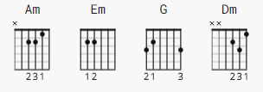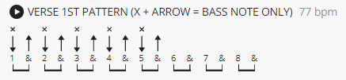

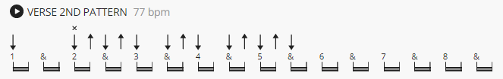

Picking:

Am Em G
e|----0-----0--------------|
B|----1-----1-----0-----0--|
G|----0-----0-----0-----0--|
D|----------------2-----0--|
A|-0-----0-----------------|
E|-------------0-----3-----|

[Verse 1]
Am Em G Am
Ain't no sunshine when she's gone
Am Em G Am
It's not warm when she's away
Em Dm
Ain't no sunshine when she's gone, and she's always gone too long
Am Em G Am
Anytime she goes away

Am Em G Am
Wonder this time where she's gone
Am Em G Am
Wonder if she's gone to stay
Em Dm
Ain't no sunshine when she's gone, and this house just ain't no home
Am Em G Am
Anytime she goes away

[Interlude]

N.C.
And I know, I know, I know, I know, I know
N.C.
I know, I know, I know, I know, I know, I know, I know
N.C.
I know, I know, I know, I know, I know, I know
N.C.
I know, I know, I know, I know, I know, I know, I know, I know
N.C.
Hey, I ought to leave the young thing alone
[Verse 2]
Am Em G Am
But ain't no sunshine when she's gone
Am Em G Am
Ain't no sunshine when she's gone
Am Em G Am
Only darkness every day
Em Dm
Ain't no sunshine when she's gone, and this house just ain't no home
Am Em G Am
Anytime she goes away
Am Em G Am
Anytime she goes away
Am Em G Am
Anytime she goes away
Am Em G Am
Anytime she goes away

