All Right Now Free Intermediate

This version lists power chords and if played on electric guitar with fuzz/phaser or clean with slap back can make even beginners sound fantastic,novice guitarists should be able to play this great song accurately and easily.

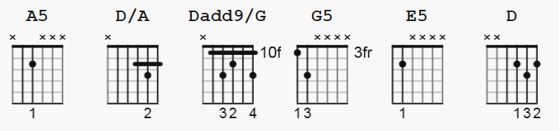

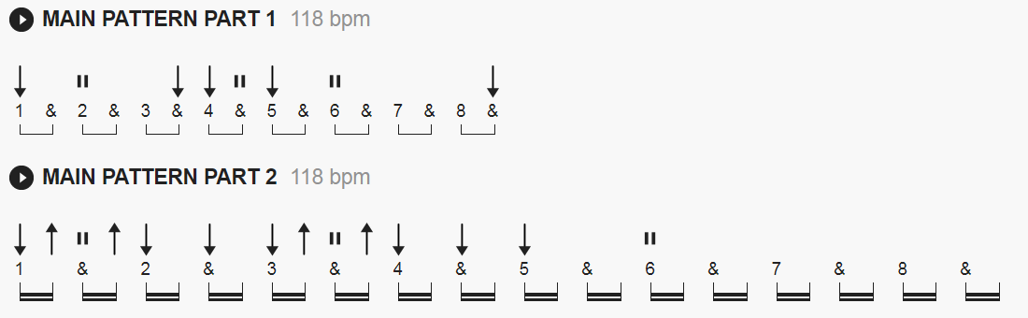

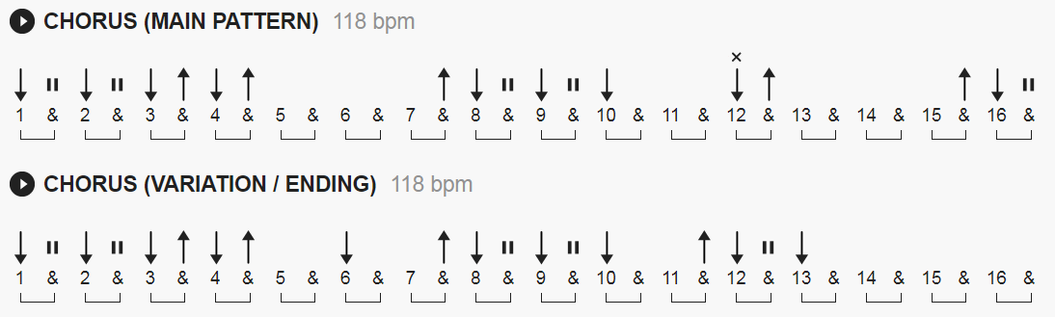

Hold the last strum of the ending chorus pattern for 2 bars on the 1st & 2nd choruses.

Using POWER chords listed below:

A5 x02255
D/A x0423x
Dadd9/G x04030
G5 3x0033
E5 022xxx

Chorus D can be a D/A
All Right Now chords start on this page

[Intro]

A5 D/A A5 Dadd9/G D/A A5
A5 D/A A5 Dadd9/G D/A A5

[Verse 1]

A5 D/A A5 Dadd9/G D A5
There she stood in the street, smiling from her head to her feet
D/A A5 Dadd9/G D A5
I said, "A-hey, what is this?",(Now baby maybe), maybe she's in need of a kiss
D/A A5 Dadd9/G D A5
I said, "A-hey, what's your name, baby?,Maybe we can see things the same
D/A A5 Dadd9/G D A5
Now don't you wait or hesitate,Let's move before they raise the parking rate

[Chorus]

A5 G5 D A5
All right now baby, it's all right now
A5 G5 D A5
All right now baby, it's all right now
A5 D/A
Let me tell you now

[Link]

A5 Dadd9/G D/A A5

[Verse 2]

A5 D/A A5 Dadd9/G D A5
I took her home to my place, watching every move on her face
D/A A5 Dadd9/G D A5
She said, "Look, what's your game, baby?,Are you tryin' to put me in shame?
D/A A5 Dadd9/G D A5
I said, "Slow, don't go so fast,Don't you think that love can last?
D/A A5 Dadd9/G D A5
She said, "Love, lord above, now you're gonna trick me in love

[Chorus]

A5 G5 D A5
All right now baby, it's all right now
A5 G5 D A5
All right now baby, it's all right now

[Music Break]
A5 A5 A5 A5

A5 G5 D A5 G5 D X 8
E5 E5

[Verse 3]

A5 D/A A5 Dadd9/G D A5
I took her home to my place, watching every move on her face
D/A A5 Dadd9/G D A5
She said, "Look, what's your game, baby?,Are you tryin' to put me in shame?
D/A A5 Dadd9/G D A5
I said, "Slow, don't go so fast,Don't you think that love can last?
D/A A5 Dadd9/G D A5
She said, "Love, lord above, now you're gonna trick me in love

[Chorus]

A5 G5 D A5
All right now baby, it's all right now
A5 G5 D A5
All right now baby, it's all right now

[Fade Out]

A5 G5 D A5
All right now baby, it's all right now
A5 G5 D A5
All right now baby, it's all right now

