All Right Now Free Beginner key A

Tuning: E A D G B E
Capo: no capo

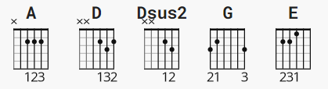

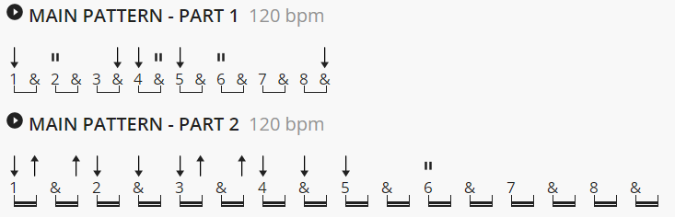

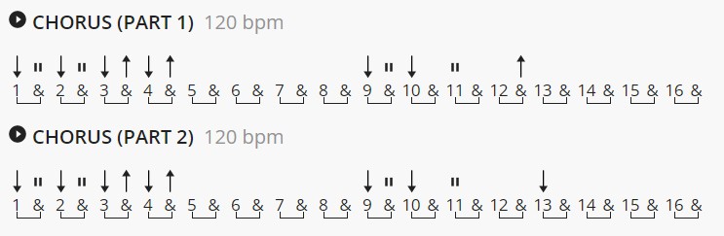

Hold the last strum at the end of the chorus for 2 bars on the 1st & 2nd choruses.

from Justinguitar:
The actual riff is played with two guitars panned left to right, the two of them synced up perfectly with their parts being ever so slightly different! Some of the chords include an A5 open chord, a D/A chord, and a Dadd11 chord ( not in this chord chart ).
----
Chord chart starts next page !
All Right Now Free

[Intro]

A D \ A Dsus2 A oh oh
A D \ A Dsus2 A

A D A
There she stood, in the street;
Dsus2 D A
Smiling from her head to her feet
A D A
I said hey, what is this?
Dsus2 D A
Now baby, maybe she's in need of a kiss?

A D A
i said hey, what is your name baby?
Dsus2 D A
Maybe we can see things the same
Dsus2 D A
Now Don't you wait, or hesitate;
Dsus2 D A
let's move before they raise the parking rate, oh!

A D A G D A
All right now, baby, it's all right now
A D A G D A
All right now, baby, it's all right now.

A D \ A Dsus2 A
Let me tell you now

A D A
I took her home, to my place;
Dsus2 D A
watching ev'ry move on her face
A D A
She said look, what's your game, baby?
Dsus2 D A
Are you tryin' to put me in shame?

A D A
I said slow, don't go so fast,
Dsus2 D A
Don't you think that love can last?
A D A
She said love, Lord above,
Dsus2 D A
now you're tryin' to trick me in love.

A D A G D A
All right now, baby, it's all right now
A D A G D A
All right now, baby, it's all right now.

Bass Solo
A D A D A G D A G D A G D A G D A

Guitar Solo
G D A G D A G D A G D A
G D A G D A G D A G D A
A D A E

Oh yeah

A D \ A Dsus2 A
Let me tell you all about it
A D \ A Dsus2 A

A D A
I took her home, to my place;
Dsus2 D A
watching ev'ry move on her face,
A D A
She said look, what's your game,
Dsus2 D A
Are you tryin' to put me in shame?

A D A
Baby, I said slow, don't go so fast,
Dsus2 D A
Don't you think that love can last?
A D A
She said love, Lord above,
Dsus2 D A
now you're tryin' to trick me in love.

A D A G D A
All right now, baby, it's all right now
A D A G D A
All right now, baby, it's all right now. 3x

We're so happy together, it's alright, it's alright..

[end]

