All Together Now Beatles key G

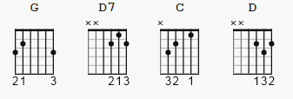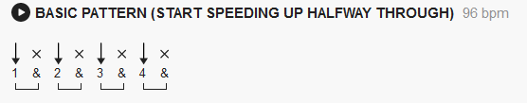
https://youtu.be/73lj5qJbrms (same key as below)

[Intro]

G
One, two, three, four
D7
Can I have a little more?
G D7 G
Five, six, seven, eight, nine, ten, I love you

[Verse 1]

G
A, B, C, D
D7
Can I bring my friend to tea?
G D7 G
E, F, G, H, I, J, I love you # strum pattern changes here

[Pre-Chorus]

boom boom boom # sound almost background: beats tbd

C
(Boom boom boom) Sail the ship
G
(Boom boom boom) Chop the tree
C
(Boom boom boom) Skip the rope
D
(boom boom boom) Look at me

[Chorus 1]

All together now (All together now) # play 4 times, one chord each
full line
G G D7 G

[Verse 2]

G
Black, white, green, red
D7
Can I take my friend to bed?
G D7 G
Pink, brown, yellow, orange, blue, I love you

[Chorus 2]

All together now (All together now) # play 8 times, one chord each time

G G D7 G G G D7 G ( spaces are for readability )

[Pre-Chorus]

boom boom boom

C
(Boom boom boom) Sail the ship
G
(Boom boom boom) Chop the tree
C
(Boom boom boom) Skip the rope
D
(boom boom boom) Look at me

[Chorus 3]

All together now (All together now) #play 11 times, one chord each time

G G D7 G G G D7 G G G D7 (spaces are for readability)

D7 G ( stretch chords and lyrics )
All together now #THE END#

