All Together Now Beatles

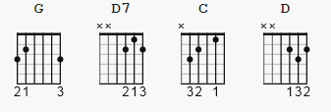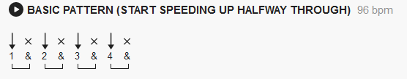
https://youtu.be/73lj5qJbrms (same key as below)

[Intro]

G
One, two, three, four
D7
Can I have a little more?
G D7 G
Five, six, seven, eight, nine, ten, I love you

[Verse 1]

G
A, B, C, D
D7
Can I bring my friend to tea?
G D7 G
E, F, G, H, I, J, I love you

[Pre-Chorus]

boom boom boom

C
(Boom boom boom) Sail the ship
G
(Boom boom boom) Chop the tree
C
(Boom boom boom) Skip the rope
D
(boom boom boom) Look at me

[Chorus 1]

G
All together now (All together now)
G
All together now(All together now)
D7
All together now(All together now)
G
All together now(All together now)

[Verse 2]

G
Black, white, green, red
D7
Can I take my friend to bed?
G D7 G
Pink, brown, yellow, orange, blue, I love you

[Chorus 2]

G
All together now (All together now)
G
All together now (All together now)
D7
All together now (All together now)
G
All together now (All together now)
G
All together now (All together now)
G
All together now (All together now)
D7
All together now (All together now)
G
All together now (All together now)

[Pre-Chorus]

boom boom boom

C
(Boom boom boom) Sail the ship
G
(Boom boom boom) Chop the tree
C
(Boom boom boom) Skip the rope
D
(boom boom boom) Look at me

[Chorus 3]

G
All together now (All together now)
G
All together now (All together now)

D7
All together now (All together now)
G
All together now (All together now)
G
All together now (All together now)
G
All together now (All together now)
D7
All together now (All together now)
G
All together now (All together now)
G
All together now (All together now)
G
All together now (All together now)
D7
All together now (All together now)

D7 G
All together now #THE END#

