Angie Rolling Stones 1973 (Goats Head Soup) key Am or G

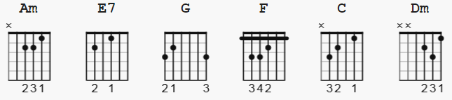
C/B= x22020

INTERMEDIATE

strum pattern: see notes at end

[Intro]:

E7 G F F-C-Dm-C C/B

Am E7 G F F-C-Dm-C-(C/B)
Angie, Angie, when will those clouds all dis-ap-pear?
Am E7 G F F-C-Dm-C
Angie, Angie, where will it lead us from here?
G Dm Am
With no loving in our souls and no money in our coats
C F G
You can't say we're satisfied
Am E7 G F F-C-Dm-C
But Angie, Angie, you can't say we never tried

Am E7 G F F C-Dm-C-(C/B)
Angie, you're beautiful, but ain't it time we said good-bye?
Am E7 G F F-C-Dm-C
Angie, I still love you, remember all those nights we cried?
G Dm Am
All the dreams we held so close seemed to all go up in smoke
C F G
Let me whisper in your ear:
Am E7 G F F-C-Dm-C
Angie, Angie, where will it lead us from here?

Am E7 G F F-C-Dm-C-(C/B)
Am E7 G F F-C-Dm-C-(C/B)

G Dm Am
Oh, Angie, don't you weep, all your kisses still taste sweet
C F G
I hate that sadness in your eyes
Am E7 G F F-C-Dm-C
But Angie, Angie, ain't it time we said good-bye?

[Instrumental]:

Am E7 G F F-C-Dm-C-(C/B)

G Dm Am
With no loving in our souls and no money in our coats
C F G
You can't say we're satisfied
Dm Am
But Angie, I still love you, baby
Dm Am
Ev'rywhere I look I see your eyes
Dm Am
There ain't a woman that comes close to you
C F G
Come on Baby, dry your eyes
Am E7 G F F-C-Dm-C
But Angie, Angie, ain't it good to be a-live?
Am E7 G F F-C-Dm-C
Angie, Angie, they can't say we never tried

----

There's a very complicated strum, with instructors doing
lots of fingering. Justinguitar has a good video.
He presents a simplistic rhythm as a building block:
( simplistic doesn't mean simple )

Am:
D DuDuD D DuDu
1 2e&a3 & 4e&a

