Annie's Song John Denver key G

This version is translated from "The Music of John Denver Made Easy for Guitar" by Allen Hart. The song is written in 3/4 time and is strummed at a moderate pace.

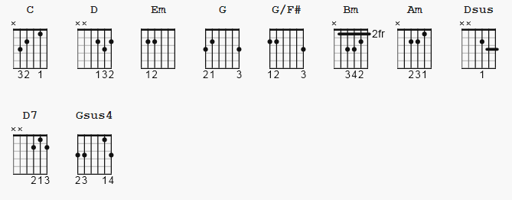

no capo time signature is 3/4

[Intro] ??? or leadin

[Verse 1]

N.C. C D Em C G G/F#
You fill up my sen-ses, like a night in the forest
Em Bm C Bm Am C D Dsus
Like the mountains in spring-time, like a walk in the rain
D D C D Em C G G/F#
Like a storm in the des-ert, like a sleepy blue ocean
Em Bm C Bm Am D7 G Gsus4 G
You fill up my sen-ses, come fill me a-gain

[Verse 2]

G C D Em C G G/F#
Come let me love you, let me give my life to you
Em Bm C Bm Am C D D
Let me drown in your laugh-ter, let me die in your arms
D D C D Em C G G/F#
Let me lay down be-side you, let me always be with you
Em Bm C Bm Am D7 G Gsus4
Come let me love you, come love me a-gain

[Instrumental ?? ] which album ?

[Verse 3]

G G C D Em C G G/F#
You fill up my sen-ses, like a night in the forest
Em Bm C Bm Am C D Dsus
Like the mountains in spring-time, like a walk in the rain
D D C D Em C G G/F#
Like a storm in the des-ert, like a sleepy blue ocean
Em Bm C Bm Am D7 G Gsus4 G G
You fill up my sen-ses, come fill me a-gain

