As Tears Go By Rolling Stones key G

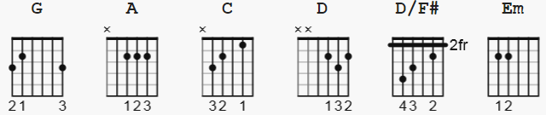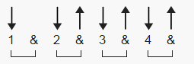

113 bpm can use Dsus4 in place of D/F# or D D DuDu

[Intro]

G A C D

[Verse]
G A C D
It is the evening of the da-ay
G A C D
I sit and watch the children pla-ay
C D
Smiling faces I can see
G D/F# Em
but not for me
C D
I sit and watch as tears go by

[Verse 2]
G A C D
My riches can't buy everythi-ing
G A C D
I want to hear the children si-ing
C D
all I hear is the sound
G D/F# Em
of rain falling on the ground
C D
I sit and watch as tears go by

[Interlude]
G A C D
G A C D
C D G D/F# Em
C D

[Verse 3]
G A C D
It is the evening of the da-ay
G A C D
I sit and watch the children pla-ay

C D
doing things I used to do
G D/F# Em
they think are new
C D
I sit and watch as tears go by

[Outro]
G A C D G
Hmm Hmm Hmm Hmm Hmm Hmm Hmm Hmm (fade)

