At The Hop Danny and the Juniors key G

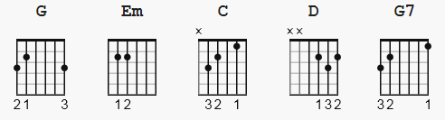 B D DuDu fast
1 2 3&4& continuous

Capo I

G Em
Bah-bah-bah-bah, bah-bah-bah-bah
C D G
Bah-bah-bah-bah. bah-bah-bah-bah, at the hop!

G
Well, you can rock it you can roll it
G7
You can stomp and you can stroll it at the hop
C
When the record starts spinnin'
G
You *calypso* and you chicken at the hop
D C G
Do the dance sensation that is sweepin' the nation at the hop

G
Ah, let's go to the hop
G7
Let's go to the hop, (oh baby)
C
Let's go to the hop, (oh baby)
G
Let's go to the hop
D C G
Come on, let's go to the hop

G
Well, you can swing it you can groove it
G7
You can really start to move it at the hop
C
Where the jockey is the smoothest
G
And the music is the coolest at the hop
D C G
All the cats and chicks can get their kicks at the hop
G
Ah, let's go to the hop
G7
Let's go to the hop, (oh baby)
C
Let's go to the hop, (oh baby)
G
Let's go to the hop
D C G
Come on, let's go to the hop

G
Well, you can rock it you can roll it
G7
You can stomp and you can stroll it at the hop
C
When the record starts spinnin'
G
You *calypso* and you chicken at the hop
D C G
Do the dance sensation that is sweepin' the nation at the hop

G
Well, you can swing it you can groove it
G7
You can really start to move it at the hop
C
Where the jockey is the smoothest
G
And the music is the coolest at the hop
D C G
All the cats and chicks can get their kicks at the hop

G
Ah, let's go to the hop
G7
Let's go to the hop, (oh baby)
C
Let's go to the hop, (oh baby)
G
Let's go to the hop
D C G
Come on, let's go to the hop

G Em
Bah-bah-bah-bah, bah-bah-bah-bah
C D G
Bah-bah-bah-bah. bah-bah-bah-bah, at the hop!

