Auld Lang Syne -- key G

This is a setup page (portrait); chords are on next pages (landscape)

The chord chart graphic does NOT match the text chord descriptors

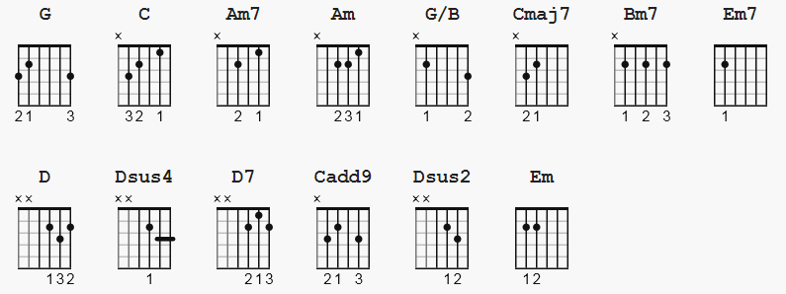
Song: Auld lang syne
Artist: Paolo Nutini
Lyrics: Robert Burns
Music: Traditional
Tabbed by: DJ 23rd Dec 2012

PLEASE NOTE: This transcription is based specifically on Paolo Nutini's
BBC4 performance. The video is at this link:
https://www.youtube.com/watch?v=zFtYKhEwYoI&feature=emb_logo
Song starts at [0:41]

Apart from some little embellishments, it's apparently closer to the
original 1788 tune which Robert Burns based his lyrics on, than the more common tune that's sung around the world on New years Eve.

In the video, Paolo misses out the second and fourth of Robert Burns verses, but I've included the complete song here.

G = 320033 C = x32013 Am7 = x02010 Am = x02210
G/B = x20033 Cmaj7 = x32003 Bm7 = x24232 Em7 = 022030
D = xx0232 Dsus4 = xx0223 D7 = xx0212 Cadd9 = x32030
Dsus2 = xx0230 Em = 022000

[Intro}
G
| / / / / | / / / / |

[Verse 1]

G G/B D Dsus2 D G G/B C Cmaj7 C
Should auld ac - quaintance be for - got, and never brought to mind,
G Em Am Am7 Bm7 C D D7
Should auld ac - quaintance be for - got, for auld lang syne

[Chorus}

G G/B D Dsus4 D G G/B C
For auld lang syne, my Jo, for auld lang syne,
Em7 Am Am7 Bm7 C D D7
We'll tak a cup o' kindness yet, for auld lang syne

[Verse 2]

G G/B D Dsus2 D G G/B C Cmaj7 C
And, surely, ye'll be your pint stowp, and, surely, I'll be mine,
G Em Am Am7 Bm7 C D D7
And we'll tak a cup o' kindness yet, for auld lang syne

[Play Chorus as above}

[Verse 3]

G G/B D Dsus2 D G G/B C Cmaj7 C
We twa hae run a - boot the braes, and pou'd the gowans fine,
G Em Am Am7 Bm7 C D D7
But we've wander'd mony a weary fitt, sin' auld lang syne

[Play Chorus as above}
[Verse 4]

G G/B D Dsus2 D G G/B C Cmaj7 C
We twa hae paidl'd in the burn, frae mornin' sun till dine,
G Em Am Am7 Bm7 C D D7
But seas, bet - ween us braid, hae roar'd, sin' auld lang syne
[Play Chorus as above}

[Verse 5]

G G/B D Dsus2 D G G/B C Cmaj7 C
And there's a hand, my trust - y fere, and gie's a hand o' thine,
G Em Am Am7 Bm7 C D D7
And we'll tak a right gude - willie waught, for auld lang syne!

[Chorus]

G G/B D Dsus4 D G G/B C
For auld lang syne, my Jo, for auld lang syne,
Em7 Am Am7
We'll tak a cup o' kindness yet,
Bm7 C G C Cadd9 G
For auld lang syne! Auld lang syne!
| / / / / | / / / / | / ||

