Baby Blue Badfinger key F# (?)

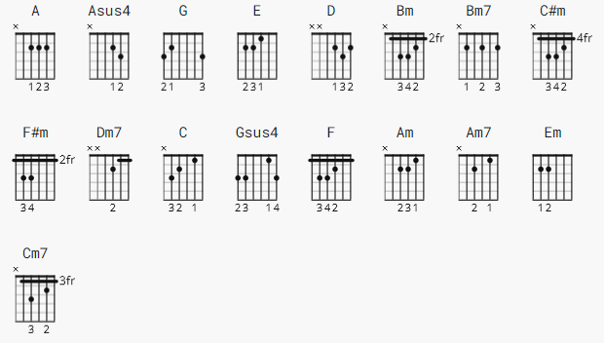

NOTE: long lines on UG mean I reduced the font size.

CAPO 2

[Intro]

A A A A Asus4 A Asus4 A A A ( A A A A - down strokes, then UDUD )

G E ( G is a fill ) E is |D--UD---|D--UD---|

[Verse 1]
(fill) (G fill)
E (2) D(1) D A G G(1) D(1) A(1) A G E
Guess I got what I deserve, kept you waiting there too long my love.
E D D A G G D A A G E
All that time without a word, did't know you'd think that I'd forget.
E E D Bm Bm Bm7 D A A A A Asus4
Or I´d regret, the special love I have for you, my baby blue.
Asus4 Asus4 A

A G E

[Verse 2]

E D D A G G D A A G E
All the days became so long, did you really think I'd do you wrong?
E D D A G G D A A G E
Dixie when I let you go, thought you'd realized I would know.
E E D Bm Bm Bm7 D A A A A Asus4 Asus4
I would show, the special love I have for you, my baby blue.
Asus4 A

A G

[Bridge]

C#m F#m Dm7 Bm Bm7 G D A A G
What Can I do, what can I say, except I want you by my side.
C#m F#m Dm7 Bm Bm7
How can I show you, show me a way?
G D C C G D A C G D A
Don't you know the times I´ve tried?

[Verse 3]

E D D A G G(1) D(1) A(1)
Guess that's all I have to say, except the feeling just grows stronger every
(G fill)
A G E
day.
E D D A G G D A A G E
Just one thing before I go, take good care baby let me know.
E E D Bm Bm Bm7 D A A
Let it flow, the special love you've had for me, my dixie dear.

Bm Bm7 G D A

[Outro]

TBD

-------------------------

G fill after A chord lick

D |-----------2--0---------------|
A |--0--2--4--------4--2--0------|
E |------------------------------|

test strokes: DudUDudu

arpeggiated D A G fill pick: D D U U D D U U

G |--------2-------------2--------|
D |-----4-----4-------2-----2-----|
A |--5-------------4--------------|
E |-------------------------------|

lick after 2nd E

e |-----------------------------------------|
B |-----------------------------------------|
G |-----------1----4----2----1--------------|
D |---2----4----------------------4----2----|
A |-----------------------------------------|
E |-----------------------------------------|

lick after D
D
e |------------------------------2-------------5---5--|
B |---------------3-------------------3--------3---3--|
G |-----------2---------2------------------2---2---2--|
D |--------4-----------------4------------------------|
A |---5-----------------------------------------------|
E |---------------------------------------------------|

NOTE: bar Bm to D major: move only picky using C-FORM

[bridge] C#m stacatto X4 F#m X4 Faug(b9) X4 Bm X4 D/A X4
Faug= xx3222

[solo] C G D A ea 1 bar, X2 except last A is once.

{arpeggiation] after last A; A Bm passingchord G D A

A Bm | | | |
e |-----------------------------|------------------------------------|
B |--------2--------------2-----|-------3----------------------------|
G |------2---2---2------2---2---|-----4---4---4--------4--------2----|
D |----2-------2------2-------2-|---4-------4--------4---4----4---4--|
A |--0--------------0-------------2----------------2--------0--------|
E |------------------------------------------------------------------|

G D A
e |------------------------2--------0-----------------|
B |----------0-----------3---3---3--2-----------------|
G |--------0---0---0---2-------2----2-----------------|
D |------0-------0---0--------------2-----------------|
A |---------------------------------0-----------------|
E |----3----------------------------------------------|

Tutorial https://www.youtube.com/watch?v=4Fd_A0DvRBw good on 03/2025
-------------------------

