Back Home Again John Denver key E

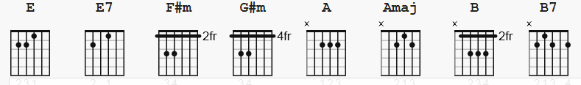

4/4 time

[Intro] none

E E7 F#m G#m A Amaj
There's a storm across the valley, clouds are rollin' in
B B7 E
The afternoon is heavy on your shoulders
E E7 F#m G#m A Amaj
There's a truck out on the four lane a mile or more away
B B7 E
The whinin' of his wheels just makes it colder

E E7 F#m G#m A Amaj
He's an hour away from ridin' on your prayers up in the sky
B B7 E
And ten days on the road are barely gone
E E7 F#m G#m A Amaj
There's a fire softly burnin', supper's on the stove
B B7 E E7 F#m G#m
But it's the light in your eyes that makes him warm

A B E E7 F#m G#m
Hey it's good to be back home again
A B E F#m G#m A
Sometimes this old farm feels like a long-lost friend
B B7 E
Yes 'n' hey, it's good to be back home again

(all verse's and chorus's use the same chords)

There's all the news to tell him, how'd you spend your time
What's the latest thing the neighbors say
And your mother called last Friday, Sunshine made her cry
You felt the baby move just yesterday

Hey it's good to be back home again - yes it is
Sometimes this old farm feels like a long-lost friend
Yes 'n' hey, it's good to be back home again
Bridge:
A B E A Amaj7
And oh, the time that I can lay this tired old body down
F#m B7 E E7
and feel your fingers feather soft upon me
A B E A Amaj7
The kisses that I live for, the love that lights my way
F#m A B B7
the happiness that living with you brings me
E E7 A
It's the sweetest thing I know of, just spending time with you
B7 E
It's the little things that make a house a home
E E7 A
Like a fire softly burnin' supper on the stove
B7 E
The light in your eyes that makes me warm

Hey it's good to be back home again
Sometimes this old farm feels like a long-lost friend
Hey, it's good to be back home again

A B7 E E7
Hey it's good to be back home a-gain ( you know it is )
A B7 E A E7 A
Sometimes this old farm feels like a long-lost friend
B7 E E
Yes 'n' hey, it's good to be back home again

[outro]:

B B7 E
I said hey it's good to be back home again

-------------
notes:
I'm posting this for those people who want to play this song without the need for a bass player. there are lots of the more difficult chords than in the other versions of this song

E E7 F#m G#m A Aadd(b2) B B7 Amaj7
e|-0----0----2----4----0----0--------2----2----0-|
B|-0----0----2----4----2----2--------4----4----2-|
G|-1----1----2----4----2----3--------4----2----1-|
D|-2----0----4----6----2----2--------4----4----2-|
A|-2----2----4----6----0----0--------2----2----0-|
E|-0----0----2----4----x----x--------x----x----x-|

was Amaj really Aaddb2 ( ?? )

