Back In The Saddle Again Gene Autry

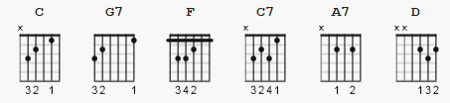

C G7 C
I m back in the saddle a-gain
F C C7
Out where a friend is a friend
F
where the Long-horn cattle feeds
G7 C A7
on the lowly jimson weed
D7 G7
I m back in the saddle a-gain

C G7 C
Rid-in the range once more
F C C7
Tot-in my old forty four
F
where you Sleep out every night
C A7
where the only law is right
D G7 C C7
I’m back in the saddle a-gain

F
Whoo pi ti yi yo
C
Rock-in to and fro
G7 C7
Back in the saddle a-gain

F
Whoo pi ti yi yay
C
I go my way
G7 C
Back in the saddle a-gain

