Back In The Saddle Again Gene Autry

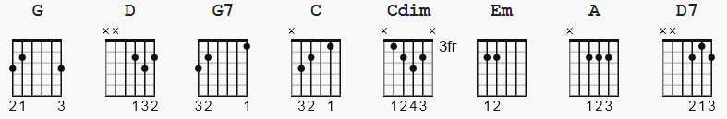

Cdim or C°

G D G G7
I'm back in the saddle again
C G G7
Out where a friend is a friend
C Cdim
Where the long-horned cattle feed
G Em
On the lowly jimson weed
A D G
I'm back in the saddle again

G D G G7
Riding the range once more
C Cdim G G7
Totin' my old '44
C Cdim
Where you sleep out every night
G Em
And the only law is right
A D G G7
I'm back in the saddle again

C
Whoopy-ti-yi-yo
G
Rocking to and fro'
D D7
I'm back in the saddle again

C Cdim
Whoopy-ti-yi-ya
G Em
I go my way
A D G
I'm back in the saddle again

