Bad Moon Rising Credence Clearwater Revival

See chords at the end for preferred. The following is taken
from elsewhere.

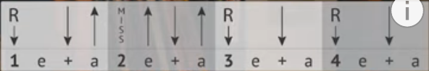

Chord progression: D A G D

[Verse intro]:

D(2) A(2) G(2) D

D(2)= x x x 11 10 10
A(2)= x x x 9 10 9
G(2)= x x x 7 8 7

[Verse 1]:

D A G D
I see a bad moon rising
D A G D
I see trouble on the way
D A G D
I see earthquakes and lightning
D A G D
I see bad times today

[Chorus]:

G
Don't go around tonight
D
'Cause it's bound to take your life
A G D
There's a bad moon on the rise

[Verse 2]:

D A G D
I hear hurricanes a blowing
D A G D
I know the end is coming soon
D A G D
I fear rivers overflowing
D A G D
I hear the voice of rage and ruin

[Repeat Chorus]

[Instrumental] 2x = 1/2 verse + chorus

[Verse 3]:

D A G D
Hope you got your things together
D A G D
Hope you are quite prepared to die
D A G D
Looks like we're in for nasty weather
D A G D
One eye is taken for an eye

[Repeat Chorus]
[Repeat Chorus]

end

---------
rhythm From Marty:

you can count how many times !!

verse: AND Intro:

D chord A chord G chord
B D uDu D D D D
1 2 3 4 1 2 3 4

chorus: G, D, A

B Du uDu
1 2 3 4

