Be My Baby Ronettes key E

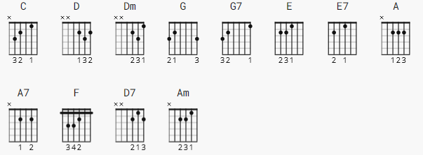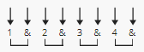

Capo 4th Fret 130 bpm

[Intro] none yet

[Verse 1]

C Dm G7
The night we met I knew I, needed you so.
C Dm G7
And if I had the chance I'd never let you go
E E7 A A7
So won't you say you love me; I'll make you so proud of me.
D D7 G G7
We'll make them turn their heads every place we go.

[Chorus]

C
So won't you please (Be my be my ...)
Am
Be my little baby (My one and only...)
F
Say you'll be my darlin' (Be my be my...)
G7
Be my baby now . Oh ho ho ho

[Verse 2]

C Dm G7
I'll make you happy baby, just wait and see,
C Dm G7
for every kiss you give me, I'll give you three.
E E7 A A7
Oh, since the day I saw you, I have been waiting for you,
D D7 G G7
You know I will adore you till eternity.
[Chorus]

C
So won't you please (Be my be my ...)
Am
Be my little baby (My one and only...)
F
Say you'll be my darlin' (Be my be my...)
G7
Be my baby now . Oh ho ho ho

C
So won't you please (Be my be my ...)
Am
Be my little baby (My one and only...)
F
Say you'll be my darlin' (Be my be my...)
G7
Be my baby now . Oh ho ho ho

[Outro] none yet

