Be My Baby Ronettes key E

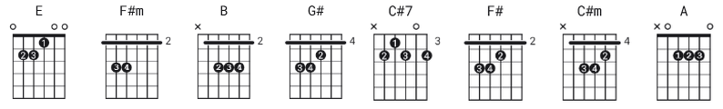

Capo:no capo Note: easier versions on UG include keys in C and D,
for capo frets 4 and 2. Also try B7 rather than B

[Intro]
???

[Verse]
E
The night we met
F#m B
I knew I needed you so
E
And if I had the chance
F#m B
I'd never let you go
G#
So won't you say you love me
C#7
I'll make you so proud of me
F#
We'll make 'em turn their heads
B
Every place we go

So won't you please

[Chorus]
E
Be my, be my baby
(Be my little baby)
C#m
My one and only baby
(Say you'll be my darling)
A
Be my, be my baby
B
(Be my baby now) My one and only baby
[Verse]
E
I'll make you happy, baby
F#m B
just wait and see
E
For every kiss you give me
F#m B
I'll give you three
G#
Oh, since the day I saw you
C#7
I have been waiting for you
F#
You know I will adore you
B
Till eternity so won't you please

[Chorus]
E
Be my, be my baby
(Be my little baby)
C#m
My one and only baby
(Say you'll be my darling)
A
Be my, be my baby
B
(Be my baby now) My one and only baby

[Solo] for practice, convert this to key C !!
e|-------------------------|
B|---------------7-7-------|
G|-9-9-8-8-6-8-9-----9-8---|
D|-------------------------|
A|-------------------------|
E|-------------------------|

