Bird On A Wire Leonard Cohen key A

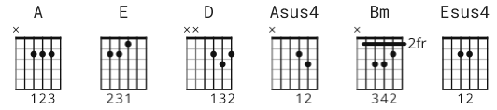

[Intro]

none

[Verse 1]

A E A D
Like a bird on the wire, like a drunk in a midnight choir
A E A Asus4 A
I have tried in my way to be free
A E A D
Like a worm on a hook, like a knight from some old-fashioned book
A E A Asus4 A
I have saved all my ribbons for thee
D A
If I, if I have been unkind
Bm A
I hope that you can just let it go by
D A
If I, if I have been untrue,
Bm E Esus4 E
I hope you know it was never to you.

[Verse 2]

A E A D
Like a baby stillborn, like a beast with his horn
A E A Asus4 A
I have torn everyone who reached out for me.
A E A D
But I swear by this song and by all that I have done wrong
A E A Asus4 A
I will make it all up to thee.
D A
I saw a beggar leaning on his wooden crutch
Bm A
He said to me, "You must not ask for so much."
D A
And a pretty woman leaning in her darkened door,
Bm E Esus4 E
She cried to me, "Hey, why not ask for more?"
[Outro]

A E A D
Like a bird on the wire, like a drunk in a midnight choir
A E D A
I have tried in my way to be free

