Blackbird Beatles key G

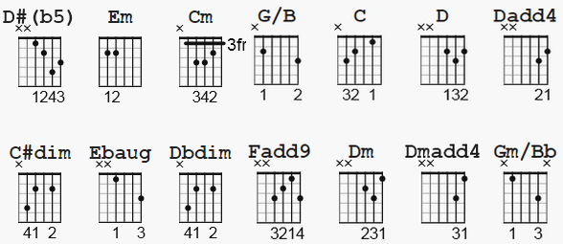

NOTES: C#dim = Dbdim ; See chord picking chart at end
not shown: Am7=x02010=x02213 C/D=xx0010=x55558

[Intro]

G Am7 G/B G*

[Verse]

G Am7 G/B G*
Blackbird singing in the dead of night
C C#dim D D#(b5) Em Ebaug
Take these broken wings and learn to fly
D Dbdim C Cm
All your life
G/B A7 C/D G
You were only waiting for this moment to arise

[Instrumental]

C G/B A7 C/D G

[Verse]

G Am7 G/B G*
Blackbird singing in the dead of night
C C#dim D D#(b5) Em Ebaug
Take these sunken eyes and learn to see
D Dbdim C Cm
All your life
G/B A7 C/D G
You were only waiting for this moment to be free
[Chorus]

F Em Dm C Gm/Bb C
Black-bird, fly
F Em Dm C Gm/Bb A7
Black-bird, fly
C/D G Am7 G/B
Into the light of the dark black night

[Instrumental]

G* C C#dim D D#(b5) Em Ebaug
D Dbdim C Cm G/B A7 C/D G

[Chorus]

F Em Dm C Gm/Bb C
Black-bird, fly
F Em Dm C Gm/Bb A7
Black-bird, fly
C/D G Am7 G/B
Into the light of the dark black night

[Instrumental]

G* G* G* ...
G Am7 G/B C G/B A7 C/D

[Verse]

G Am7 G/B G*
Blackbird singing in the dead of night
C C#dim D D#(b5) Em Ebaug
Take these broken wings and learn to fly
D Dbdim C Cm
All your life
G/B A7 C/D G
You were only waiting for this moment to arise
C G/B A7 C/D G
You were only waiting for this moment to arise
C G/B A7 C/D G
You were only waiting for this moment to arise

END of score: notes next page

Chord forms which are actually fingerpicked :

G 3xx00x
Am7 x0x01x
G/B x2x03x
G* x-10-x-0-12-x
C x3x05x
C#dim/Dbdim x4x0x3
D x5x07x (Dadd4)
D#(b5) x6x0x5
Em x7x08x
Ebaug x6x08x (implied, no 5th is played)
Cm x3x04x
A7 x0x02x
C/D xx001x (no 3rd = D7sus4)
F x-8-x-0-10-x (Fadd9)
Dm x5x06x (Dmadd4)
Gm/Bb x1x03x

