Blue Bayou Rondstadt key A

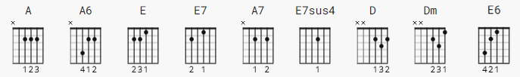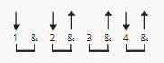 95 bpm

Capo 2

[Intro]
TBD

[Verse 1]
A A6 A
I feel so bad, I got a worried mind;
E E7
I'm so lonesome all the time
E E7 A
Since I left my baby behind on Blue Bayou;
A
Saving nickels, saving dimes,
E
Working till the sun don't shine,
E E7 A
Looking forward to happier times on Blue Bayou.

[Chorus]
A A A7 E7
I'm going back someday, come what may, to Blue Bayou,
E7sus4 E7 E7 A
Where the folks are fine, and the world is mine on Blue Bayou.
A A7
Where those fishing boats with their sails afloat,
D Dm
If I could only see
A E A A
That familiar sunrise through sleepy eyes, how happy I'd be.

[Verse 2]
A A
Gonna see my baby again;
E E7
Gonna be with some of my friends
E E7 A
Maybe I'll feel better again on Blue Bayou
A A
Saving nickels, saving dimes,
E
Working till the sun don't shine,
E A
Looking forward to happier times on Blue Bayou.

[Chorus]
A A A7 E7
I'm going back someday, come what may, to Blue Bayou,
E7sus4 E7 E7 A
Where the folks are fine, and the world is mine on Blue Bayou.
A A7
Where those fishing boats with their sails afloat,
D Dm
If I could only see
A E A A
That familiar sunrise through sleepy eyes, how happy I'd be.

[Solo]

A A E7 E7
E7 E7 A A

[Coda]
A A7
Oh, that boy of mine by my side,
D Dm
The silver moon and the evening tide;
A E A
Oh, some sweet day, gonna take away this hurtin' inside.
E E6 E
Well, I'd never be blue, my dreams come true
E7 E7 A A
On Blue Bay - ou.

