Blue Christmas key E
and a 2nd version key D next sheet

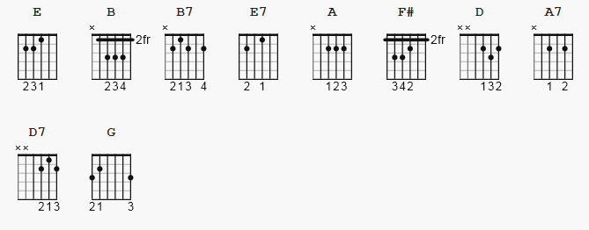

E B
I'll have a blue Christmas without you
B7 E
I'll be so blue thinking about you
E7 E A F#
Decorations of red on a green Christmas tree
B7 B7 B
Won't be the same dear, if you're not here with me

B7 E B
And the when those blue snowflakes start falling
B7 E
That's when those blue memories start calling
E7 E A F#
You'll be doing all right, with your Christmas of white
B7 E
But I'll have a blue, blue, blue, blue Christmas

[break]

E B B7 E

E7 E A F#
You'll be doing all right, with your Christmas of white
B7 E
But I'll have a blue, blue, blue, blue Christmas

-> REPEAT THE WHOLE THING AGAIN

THEN -> REPEAT THE LAST 2 LINES-END

see version 2 in key D next page
--
Blue Christmas key D Version 2

Capo II

D A
I'll have a blue Christmas without you
A7 D
I'll be so blue thinking about you
D7 D G E
Decorations of red on a green Christmas tree
A7 A
Won't be the same dear, if you're not here with me

A7 D A
And when those blue snowflakes start falling
A7 D
That's when those blue memories start calling
D7 D G E
You'll be doing all right, with your Christmas of white
A7 D
But I'll have a blue, blue, blue, blue Christmas

D A A7 D

D7 D G E
You'll be doing all right, with your Christmas of white
A7 D
But I'll have a blue, blue, blue, blue Christmas

