Blue Moon Misc Traditional/Richard Rodgers and Lorenz Hart

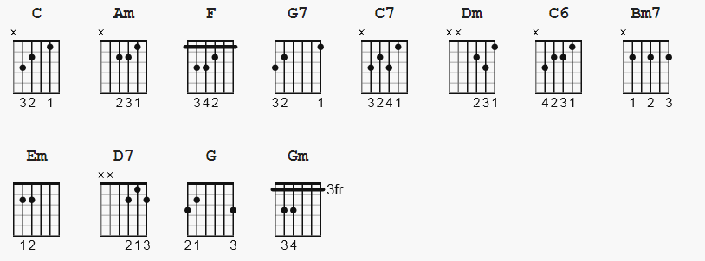

[Verse 1]

C Am F
Blue moon,
G7 C Am F
You saw me standing alone.
G7 C Am F
Without a dream in my heart,
G7 C Am F G7
Without a love of my own.

C Am F
Blue moon,
G7 C Am F
You knew just what I was there for,
G7 C Am F
You heard me saying a prayer for,
G7 C F C C7
Someone I really care for.

[Chorus]

Dm G7 C Am
And then there suddenly appeared before me.
Dm G7 C
The only one my heart could ever hold.
C6 Bm7 Em
I heard somebody whisper, please adore me.
C D7 G G7
And when I looked, the moon had turned to gold.

[Verse 2]

C Am F
Blue moon,
G7 C Am F
Now I'm no longer alone.
G7 C Am F
Without a dream in my heart,
G7 C F C C7
Without a love of my own.

[Chorus]
Dm G7 C Am
And then there suddenly appeared before me.
Dm G7 C
The only one my heart could ever hold.
C6 Bm7 Em
I heard somebody whisper, please adore me.
C D7 G G7
And when I looked, the moon had turned to gold.

[Verse 3]

C Am F
Blue moon,
G7 C Am F
Now I'm no longer alone.
G7 C Am F
Without a dream in my heart,
G7 C F C
Without a love of my own.

[Outro]

Gm C
Blue.............Moon

