Blue Moon key D7 chords prob need realigning

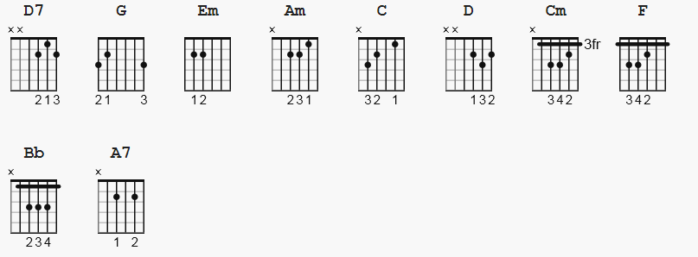

[Verse 1]

D7 G Em
Blue moon
Am D7 G Em
You saw me standing alone
Am D7 G Em
Without a dream in my heart
Am C G Em Am
Without a love of my own

D7 G Em
Blue moon
Am D7 G Em
You knew just what I was there for
Am D7 G Em
You heard me saying a prayer for
C D G C G
Someone I really care for

[Chorus]

Am D7 G
And then there suddenly appeared before me
Am D7 G
The only one my heart could ever hold
Cm F Bb
I heard somebody whisper please adore me
D A7 D (A7) D7
And when I looked the moon had turned to gold

[Verse 2]

G Em
Blue moon
Am D7 G Em
Now I'm no longer alone
Am D7 G Em
Without a dream in my heart
Am D7 G C G
Without a love of my own

[Chorus]

Am D7 G
And then there suddenly appeared before me
Am D7 G
The only one my heart could ever hold
Cm F Bb
I heard somebody whisper please adore me
D A7 D (A7) D7
And when I looked the moon had turned to gold

[Verse 3]

G Em
Blue moon
Am D7 G Em
Now I'm no longer alone
Am D7 G Em
Without a dream in my heart
Am D7 G C G
Without a love of my own

