Blueberry Hill Shakin' Stevens Live 1987 on BBC.

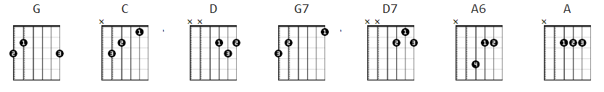

strum: D DuDuDu

[Intro]: 1 full strum: wait 1/2 count: continue

[#1].
G C G
I found my thrill on Blueberry Hill..
D G C G
On Blueberry Hill, where I found you.
G7 C G C G
The moon stood still, on Blueberry Hill.
D D7 G
And lingered until, my dreams came true.

[CHORUS]:
G D7 G D D7 G
The wind in the willow played..love's sweet melo..dy.
A7 A6 A A7 D7
But all of those vows we made, were never to be.

[#2].
D D7 C G
Though we're apart, you're part of me still..
D G
for you were my thrill, on Blueberry Hill.

(STOP)

[CHORUS]:
G D7 G D G
The wind in the willow played..love's sweet melo..dy.
D7 A6 A A7 D7
But all of those vows we made, were never to be. (stop)

[#3].
D D7 C G
Though we're apart, you're part of me still..
D G C G D G
for you were my thrill, on Blueberry Hill.

D G C G D G
for you were my thrill, on Blueberry Hill.

[outro] tbd

Translation to the Domino recording seems to be IN KEY (B)
but also can be:
C G
G D
D A, A7
A E, E6 E6=022120 ( E plus Bstring fret 2 )

opening riff that seems MOSTLY to coincide with the Fats
recording in G and some of the melody: you can pick and choose.

e|------------1---1--3333----3-3---3-1---1-1-1---------------|
B|------3---3---3----------------3-------------3-1--1--------|
G|--3-3---3-------------------------------------------3-2-3--|
D|-----------------------------------------------------------|
A|-----------------------------------------------------------|
E|-----------------------------------------------------------|

