Breathe (Acoustic) Pink Floyd key Em

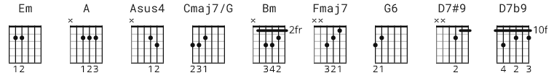

This is a tab based off an acoustic performance by David Gilmour from a
documentary entitled "Dark Side of the Moon"
http://www.youtube.com/watch?v=-W0NN28NbQo

CHORDS:

Em (022000)
A (002220)
Asus4 (002230)
Cmaj7/G (332000)
Bm (224432)
Fmaj7* (133210)
G6* (355430)
D7#9 (054560)
D7b9 (054540)

*Top note is played by thumb

[Verse 1]

Em A Asus4 A
Breathe, breathe in the air,
Em A Asus4 A
Don't be afraid to care
Em A Asus4 A
Leave, but don't leave me
Em A Asus4 A
Look around choose your own ground

[Chorus 1]

Cmaj7/G
For long you'll live and high you fly
Bm
and smiles you'll give and tears you'll cry
Fmaj7
and all you touch and all you see
G6 D7#9 D7b9
Is all your life will ever be

[Verse 2]

Em A Asus4 A
Run, rabbit run,
Em A Asus4 A
dig that hole, forget the sun
Em A Asus4 A
and when at last the work is done,
Em A Asus4 A
don't sit down it's time to dig another one
[Chorus 2]

Cmaj7/G
For long you'll live and high you'll fly,
Bm
But only if you ride the tide,
Fmaj7
And balanced on the biggest wave,
G6 D7#9 D7b9
You race toward an early grave

[END]
Em

