Brown Eyed Girl Van Morrison key G

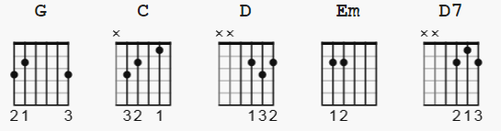

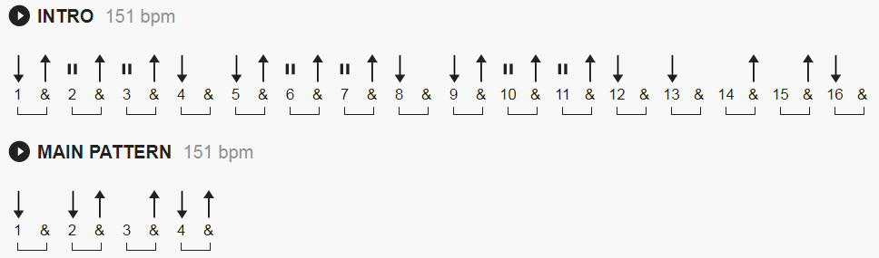

[Intro] (SEE notes)
G C G D
G C G D

[Verse 1]
G C G D
Hey where did we go, days when the rains came
G C G D
Down in the hollow, playin' a new game
G C G D
Laughin' and a-runnin' hey, hey, skippin’ and a-jumpin’
G C G D C
In the misty mornin' fog with, ah, our hearts thumpin' and you
D G Em C D G D7
My brown-eyed girl, you’re my brown-eyed girl

[Verse 2]
G C G D
Whatever happened, to Tuesday is so slow
G C G D
Goin’ down the old mine with a transistor radio
G C G D
Standin’ in the sunlight laughin’, hidin’ behind a rainbow's wall
G C G D C
Slippin’ and a-slidin’ all along the waterfall with you
D G Em C D G
My brown-eyed girl, you’re my brown-eyed girl

[Chorus]
D7
Do you remember when we used to sing
G C G D
Sha la la la la la la la la la la te da (just like that)
G C G D G
Sha la la la la la la la la la la te da, la te da

[Bass Solo]
G C G D

[Verse 3]
G C G D
So hard to find my way, now that I'm all on my own
G C G D
I saw you just the other day, my, how you have grown
G C G D
Cast my memory back there, Lord, sometimes I'm overcome thinkin’ about
G C G D C
Makin’ love in the green grass, behind the stadium with you
D G Em C D G
My brown-eyed girl, a-you’re my brown-eyed girl

[Chorus]
D7
Do you remember when we used to sing
G C G D
Sha la la la la la la la la la la te da
G C G D
Sha la la la la la la la la la la te da
G C G D
Sha la la la la la la la la la la te da
G C G D
Sha la la la la la la la la la la te da

(fade out)

------------
NOTES:

[Main]:
You can play a mix of D and D7 to get sort of a fill at the end
of each verse;

You can also use a Cadd9 where convenient - x32030

[Intro] ( 11 pt font )

G C G D
e|-----------------------8--10--12--10--8---------------------------------|
B|--8--10--12--10--8--------------------------8--10--12--10--8~---7-------|
G|-----------------------9--10--12--10--9----------------------------7----|
D|--9--10--12--10--9--------------------------9--10--12--10--9----7-------|
A|------------------------------------------------------------------------|
E|------------------------------------------------------------------------|

[Intro 2 alternate ?]:

G C
--7--8----10----8---7----|12--13----15----13----12---------
--8-10----12---10---8----|13--15----17----15----13---------
-------------------------|--------------------------------- repeat
-------------------------|---------------------------------
-------------------------|---------------------------------
-------------------------|---------------------------------

D G
5---2---3---5------------|-3-------------------------------
7---3---5---7------------|-0-------------------------------
-------------------------|-0-----(now go into verse)-------
-------------------------|-0-------------------------------
-------------------------|-2-------------------------------

Or You can play this
(you may find this is a little closer to the recorded version)

--3--5--7--5--3---|-6--8--10--8--6
------------------|---------------
--4--5--5--5--4---|-7--8--10--8--6 etc.
------------------|---------------
------------------|---------------
------------------|---------------

