By and By Caamp key A (capo 2)

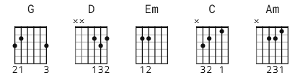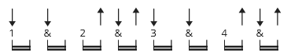

[Intro]
G G

[Verse 1]
G D
Driving through West Virginia
Em C
And I've seldom been thinner
G D
With that chip on my shoulder
Em C
And this past year I got so much older

[Instrumental]
G D Em C

[Verse 2]
G D
Looking back over my life
Em C
Spent the most of it tongue-tied
G D
And I wish I'd had more time
Em C
Listening to you speak your mind

[Chorus]
G
Now I'm thinking 'bout her every day
D
On my mind atypical way
Em C
Are you a life force
G
Thinking 'bout her every day
D
On my mind atypical way

Em C
Are you a life force

[Instrumental]
G D Em C x2

[Verse 3]
G D
Drinking coffee black as iron
Em C
And I couldn't be much higher
G D
Without falling out of my chair
Em C
I've been so numb for so many years

[Chorus]
G
Now I'm thinking 'bout her every day
D
On my mind atypical way
Em C
Are you a life force
G
Thinking 'bout her every day
D
On my mind atypical way
Em C
Are you a life force

[Bridge]
Am D
And it's so easy
G
To be blinded by the light
Em
To feel lonely in the night
Am D
And it's blowing in the breeze, babe
G
I got dust in my eyes
Em
And rust in my mind
Am
I'll be home come next spring
D
Won't you say you love me later
G G
By and by

[Instrumental]
Am D G Em
Am D G G

[Verse 4]
G D
Looking back over my life
Em C
Spent the most of it tongue-tied
G D
Pulling my belt tight
Em C
It's just me and the stars tonight
G D
Two fingers and a tight line
Em C
Keep my head above the alpine
G D
Just wish I'd spent more time
Em C
Listening to her speak her mind

[Chorus]
G
Thinking 'bout her every day
D
On my mind atypical way
Em C
Are you a life force
G
Thinking 'bout her every day
D
On my mind atypical way
Em C
Are you a life force

G
Thinking 'bout her every day
D
On my mind atypical way
Em C
Are you a life force
G
Thinking 'bout her every day
D
On my mind atypical way
Em C
Are you a life force
G
For me

[Outro]
(G) D Em C
G D Em C
G
X

