Cecilia Simon & Garfunkle chords shown in C; capo 4 ( key E )

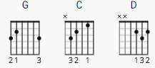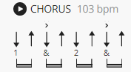

[Chorus]

G C G
Cecilia, you're breaking my heart
C G D
You're shaking my confidence daily
C G C G
Oh Cecilia, I'm down on my knees
C G D
I'm begging you please to come home
G C G
Cecilia, you're breaking my heart
C G D
You're shaking my confidence daily
C G C G
Oh Cecilia, I'm down on my knees
C G D
I'm begging you please to come home
G
Come on home

[Verse 1]

G C D G
Making love in the afternoon with Cecilia
C D G
Up in my bedroom
C D
I got up to wash my face
G C
When I come back to bed
D G
Someone's taken my place ...

[Chorus]

G C G
Cecilia, you're breaking my heart
C G D
You're shaking my confidence daily
C G C G
Oh Cecilia, I'm down on my knees
C G D
I'm begging you please to come home
G
Come on home
[Interlude]

G C G C G D
Bo po bo bo ...

[Verse 2]

C G C G
Jubilation, she loves me again
C G D
I fall on the floor and I'm laughing
C G C G
Jubilation, she loves me again
C G D
I fall on the floor and I'm laughing

[Outro]

C G C G C G D

