Chicken Fried Zac Brown Band

difficulty: advanced beginner

No capo

tuning Eb (Eb Ab Db Gb Bb Eb)

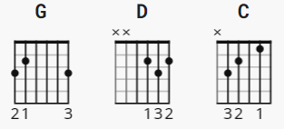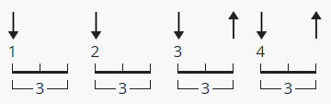

[Intro]
|G |D |C |D | or or (G D C G D)

G ( start on chicken or fried ? )
You know I like my chicken fried
D
Cold beer on a Friday night
C
A pair of jeans that fit just right
G D
And the radio up

[Instrumental]

|G |D |C |D | 2X xxx or (G D C G D)

[Verse 1]
G D C
Well I was raised up beneath the shade of a Georgia Pine
D
And that's home you know
G D C D
Sweet tea, pecan pie, and homemade wine where the peaches grow
G D C D
And my house it's not much to talk about
G D C D
But it's filled with love that's grown in southern ground

[Chorus]
G
And a little bit of chicken fried
D
Cold beer on a Friday night
C
A pair of jeans that fit just right
G D
And the radio up
G
I like to see the sun rise
D
See the love in my woman's eyes
C
Feel the touch of a precious child
G D
And know a mother's love

[Verse 2]
G D C D
It's funny how it's the little things in life that mean the most
G D C D
Not where you live, what you drive, or the price tag on your clothes
G D
There's no dollar sign on a peace of mind
C D
This I've come to know
G D
So if you agree, have a drink with me
C D
Raise you glasses for a toast

[Chorus]
G
To a little bit of chicken fried
D
Cold beer on a Friday night
C
A pair of jeans that fit just right
G D
And the radio up
G
I like to see the sun rise
D
See the love in my woman's eyes
C
Feel the touch of a precious child
G D
And know a mother's love

[Instrumental/solo]

|G |D |C |D | X3 or G D C G D

[Verse 3] (change of tempo, chord order = chorus)
G
I thank God for my life
D
And for the stars and stripes
C G D
May freedom forever fly, let it ring
G
Salute the ones who died
D C
The ones that give their lives so we don't have to sacrifice
G D
All the things we love

[Chorus]
G
Like our chicken fried
D
Cold beer on a Friday night
C
A pair of jeans that fit just right
G D
And the radio up
G
I like to see the sun rise
D
See the love in my woman's eyes
C
Feel the touch of a precious child
G D
And know a mother's love

[Chorus 2]
G
Getcha a little chicken fried
D
Cold beer on a Friday night
C
A pair of jeans that fit just right
G D
And the radio up
G
I like to see the sun rise
D
See the love in my woman's eyes
C
Feel the touch of a precious child
G D
And know a mother's love

[outro tbd]

---------------
NOTES:

Intro counts G D C G D
8 8 8 4 4
verses: G D C D 4 counts ea.
chorus: G D C G D
8 8 8 4 4
sound: vlc player try +1.0 semitone

