China Grove Doobie Brothers

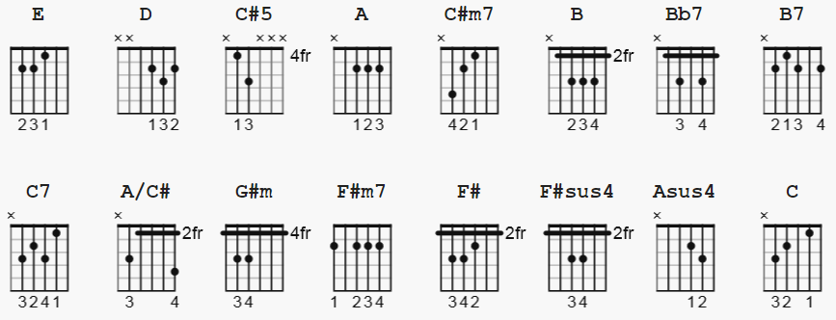
C#5 alternate=4466xx fingers 1,4 ; Asus4=Dsus2 ; F#m7=A/F#

[Intro]
E E E E D C#5 A E E x3
E E E E D C#5 A

[Verse 1]
E E D C#5 A E
When the sun comes up on a sleepy little town Down around San Antone
E D C#5 A E
All the folks risin’ for another day ‘round about their homes
C#m7 B A Bb7 B7 C7
The people in the town are strange and they’re proud from where they came

[Chorus]
E E D A/C# E
We'll your talkin’ ‘bout (talkin’ ‘bout) the China Grove Oh, oh, oh
D A/C# E E D A/C# E
Oh, oh China Grove

[Verse 2]
E E
Well the preacher and the teacher Lord they’re a caution
D C#5 A E E
They are the talk of the town when the gossip get a flyin’
E D C#5 A E
And they ain't lyin’ when the sun goes fallin’ down
C#m7 B A Bb7 B7 C7
They say that the father’s insane and dear Missus Perkins a game

[Chorus]
E E D A/C# E
We'll your talkin’ ‘bout, (talkin’ ‘bout) the China Grove Oh, oh, oh
D A/C# E
, oh China Grove

[Bridge]
G#m B C#m7
But every day there’s a new thing comin’
F#m7 C#m7
The ways of a oriental view
C#m7 C#m7
The sheriff and his buddies with their samurai swords
F# F#sus4 F# F#sus4 F#
You can even hear the music at night
G#m B C#m7
Although it’s apart of a lone star state
F#m7 C#m7
People don't seem to care
A Asus4 A C D E C D E
They just keep on lookin’ to the east

[Solo Сhords]
E E E E D C#5 A E E x6
C#m7 B E B A Bb7 B7 C7

[Outro]
E E D A/C# E
Talkin’ ‘bout, (talkin’ ‘bout) the China Grove Oh, oh, oh
D A/C# E D A/C# E
Oh, oh China Grove

