Closing Time Semisonic

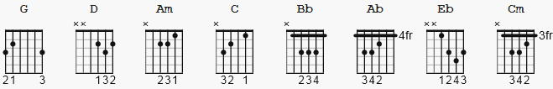

VERSE CHORUS

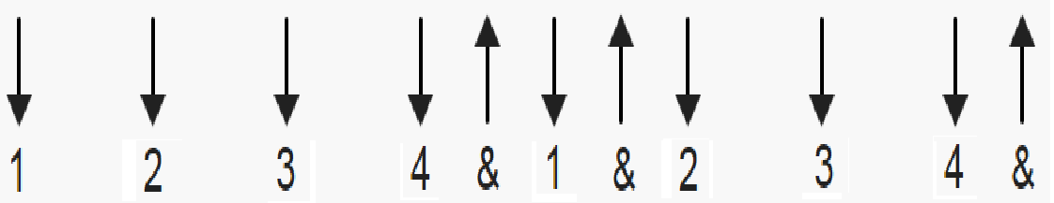 92 bpm 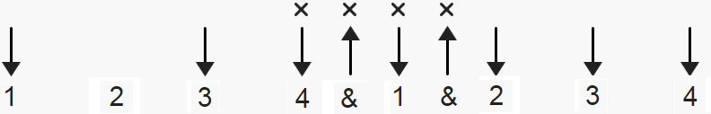

all chords are 1 bar except where noted (if any)

[Intro]

G D Am C
G D Am C
G D Am C
G D Am C

[Verse]

G D
Closing time
Am C G D Am C
Open all the doors and let you out into the world
G D
Closing time
Am C G D Am C
Turn all of the lights on over every boy and every girl
G D
Closing time
Am C G D Am C
One last call for alcohol so finish your whiskey or beer
G D
Closing time
Am C G D Am C
You don't have to go home but you can't stay here

[Chorus]

G D Am C
I know who I want to take me home
G D Am C
I know who I want to take me home
G D Am C
I know who I want to take me home
G D Am C
Take me home
[Verse]

G D
Closing time
Am C G D Am C
Time for you to go out to the places you will be from
G D
Closing time
Am C G D Am C
This room won't be open till your brothers or your sisters come
G D Am C
So gather up your jackets move it to the exits
G D Am C
I hope you have found a friend
G D
Closing time
Am C G D Am
Every new beginning comes from some other beginning's end...
C
yeah

[Chorus]

G D Am C ; comments- see bridge notes
I know who I want to take me home ; C D E G octaves
G D Am C
I know who I want to take me home ; E F# G B octaves
G D Am C
I know who I want to take me home ; C D E G
G D Am C
Take me home ; E F# G B

[Bridge] Are these flats guitar or a synth ??

Bb Ab Eb Cm with Bb and Ab, strum from 6th string AND,
Bb Ab Eb Cm with Eb and Cm, strum from 5th string;;
Bb Ab Eb Cm justin plays an octave chord here; strings 5,3
G D Am C mute the other string chords C D E G going
G D Am C up the neck; then further up E F# G B

[Solo]
G D Am C
G D Am C
G D Am C
G D Am C

G D
Closing time
Am C G D Am
Time for you to go out to the places you will be from

[Chorus]

G D Am C
I know who I want to take me home
G D Am C
I know who I want to take me home
G D Am C
I know who I want to take me home
G D Am C
Take me home

G D Am C
I know who I want to take me home
G D Am C
I know who I want to take me home
G D Am C
I know who I want to take me home
G D Am C
Take me home

[Instrumental]

G D Am C
G D Am C
G D Am C

[Outro]

G D
Closing time
Am C G D Am C G
Every new beginning comes from some other beginning's end

------------------------------------------

optional [Bridge]: ( haven't figure out exactly how it fits )

G C Am C D E G

G C Am E F# G B

2 4 4 1 1 1 1 counts

note: the first G can be 1.5 to 2 beats to fit

C and Am are 4 counts each

C D E G and D F# G B are OCTAVES, 1 count (strum) each

suggested lesson:

https://www.justinguitar.com/songs/semisonic-closing-time-chords-tabs-guitar-lesson-bs-422

