Closing Time Semisonic

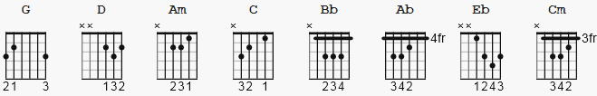

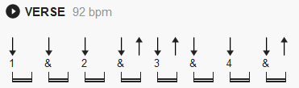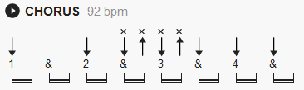
Closing Time Semisonic

[Intro]

G D Am C
G D Am C
G D Am C
G D Am C

[Verse]

G D
Closing time
Am C G D Am C
Open all the doors and let you out into the world
G D
Closing time
Am C G D Am C
Turn all of the lights on over every boy and every girl
G D
Closing time
Am C G D Am C
One last call for alcohol so finish your whiskey or beer
G D
Closing time
Am C G D Am C
You don't have to go home but you can't stay here

[Chorus]

G D Am C
I know who I want to take me home
G D Am C
I know who I want to take me home
G D Am C
I know who I want to take me home
G D Am C
Take me home

[Verse]

G D
Closing time
Am C G D Am C
Time for you to go out to the places you will be from
G D
Closing time
Am C G D Am C
This room won't be open till your brothers or your sisters come
G D Am C
So gather up your jackets move it to the exits
G D Am C
I hope you have found a friend
G D
Closing time
Am C G D Am
Every new beginning comes from some other beginning's end...
C
yeah

[Chorus]

G D Am C
I know who I want to take me home
G D Am C
I know who I want to take me home
G D Am C
I know who I want to take me home
G D Am C
Take me home

[Bridge]

Bb Ab Eb Cm
Bb Ab Eb Cm
Bb Ab Eb Cm
G D Am C
G D Am C

[Solo]
G D Am C
G D Am C
G D Am C
G D Am C

G D
Closing time
Am C G D Am
Time for you to go out to the places you will be from

[Chorus]

G D Am C
I know who I want to take me home
G D Am C
I know who I want to take me home
G D Am C
I know who I want to take me home
G D Am C
Take me home

G D Am C
I know who I want to take me home
G D Am C
I know who I want to take me home
G D Am C
I know who I want to take me home
G D Am C
Take me home

[Instrumental]

G D Am C
G D Am C
G D Am C

[Outro]

G D
Closing time
Am C G D Am C G
Every new beginning comes from some other beginning's end

