Crocodile Rock Elton John

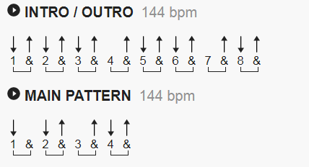

[Intro]
G G Em Em C C D D

[Verse 1]

G Bm
I remember when rock was young, me and Susie had so much fun
C D
Holding hands and skimmin' stones had a old gold Chevy & a place of my own
G Bm
But the biggest kick I ever got was doin' a thing called the Crocodile Rock
C D
While the other kids were rockin' 'round the clock we were hoppin' and

boppin' to the Crocodile Rock, well

[Chorus]

Em A7
Crocodile Rockin' is something shockin' when your feet just can't keep still
D7 G
I never knew me a better time and I guess I never will.
E A7
Oh, Lawdy mamma those Friday nights when Susie wore her dresses tight and
D7 F C F C F C
the Crocodile Rockin' was out of sight.

[Interlude]
G G Em Em C C D D

[Verse 2]

G Bm
But the years went by and rock just died, Susie went and left me for some foreign guy,
C D
Long nights cryin' by the record machine dreamin' of my Chevy & my old blue jeans but they'll
G Bm
Never kill the thrills we got burnin' up to the Crocodile Rock,
C D
Learning fast as the weeks went past, we really thought the Crocodile Rock would last, well

[Chorus]

Em A7
Crocodile Rockin' is something shockin' when your feet just can't keep still
D7 G
I never knew me a better time and I guess I never will.
E A7
Oh, Lawdy mamma those Friday nights when Susie wore her dresses tight and
D7 F C F C F C
the Crocodile Rockin' was out of sight.

[Interlude]
G G Em Em C C D D

[Verse 3]

G Bm
I remember when rock was young, me and Susie had so much fun
C D
Holding hands and skimmin' stones had a old gold Chevy & a place of my own
G Bm
But the biggest kick I ever got was doin' a thing called the Crocodile Rock
C D
While the other kids were rockin' 'round the clock we were hoppin' and

boppin' to the Crocodile Rock, well

[Chorus]

Em A7
Crocodile Rockin' is something shockin' when your feet just can't keep still
D7 G
I never knew me a better time and I guess I never will.
E A7
Oh, Lawdy mamma those Friday nights when Susie wore her dresses tight and
D7 F C F C F C
the Crocodile Rockin' was out of sight.

[Outro]
G G Em Em C C D D

RIFF - if you know how it goes, the extra notes you throw in at the
appropriate spots are -
E on the G chord
F# on the Em and C chords
G on the D chord [dropping the F#]

BASS - Walk up from the root to the sixth on each 1/4 note, so in each
bar the notes are -
G G B D E
Em E G B D
C C E G A
D D F# A B

