Different Drum Stone Poneys (Linda Rondstat) key C + capo3

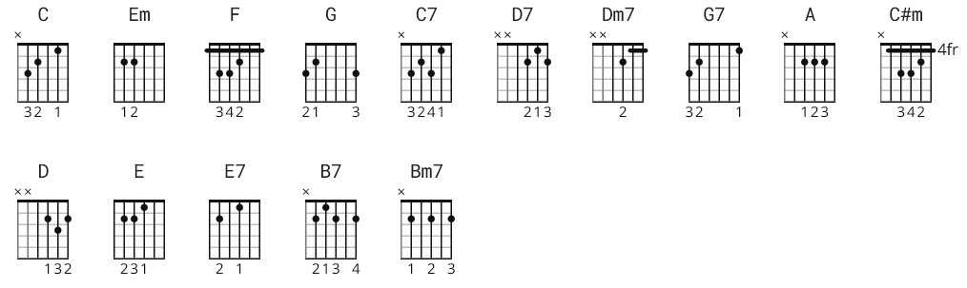

C Em F G 3x *

C Em F G C Em
You and I, travel to the beat of a different drum
F G C Em
Oh can't you tell by the way I run
F G C Em
Every time you make eyes at me
F G
Wo-oh

C Em F G C Em
You cry, and moan, and say it will work out
F G C Em
But honey child, I've got my doubts
F G
You can't see the forest for the trees

F
Oh don't get me wrong

It's not that I knock it
G
It's just that I am not in the market
F G C C7
For a girl who wants to love only me

F G
Yes, and I ain't saying you ain't pretty
C Em F C
All I'm saying is I'm not ready
D7
For any person place or thing
Dm7 G G7
To try and pull the reins in on me
C Em F G
So good-bye, I'll be leaving
C Em F G
I see no sense, in this crying and grieving
C Em
We'll both live a lot longer
F G7 C
If you live without me

C Em F G (harpsichord)

F
Oh don't get me wrong

It's not that I knock it
G
It's just that I am not in the market
F G C C7
For a girl who wants to love only me

F G
Yes, and I ain't saying you ain't pretty
C Em F C
All I'm saying is I'm not ready
D7
For any person place or thing
Dm7 G G7
To try and pull the reins in on me

C Em F G
So good-bye, I'll be leaving
C Em F G
I see no sense, in this crying and grieving
C Em
We'll both live a lot longer
F G7 C
If you live without me

C Em F G 3x

* Alternate:

Capo III

C = A
Em = C#m
F = D
G = E
G7 = E7
D7 = B7
Dm7 = Bm7

