Don't Tell Me What To Do Pam Tillis key G

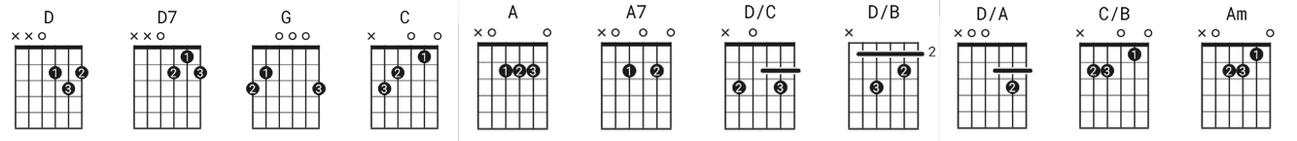

[Intro]
D D7 G

[Verse 1]

G C D
We tried and we tried but it's over
D D7 G D
Guess I didn't fit the image in your mind
G C D
Now you tell me to find another lover
A A7 D D/C D/B D/A
Oh but baby aren't you getting out of line

[Chorus]

G C D
Don't tell me what to do
D7 G D
You've already said we are through
G
I'm a page that you have turned
C C/B Am
I'm no longer your concern
D
So don't tell me what to do
D7 G
I'll love you forever if I want to

[Verse 2]

G C D
You're no longer in charge of my thinking
D D7 G D
You're already in love with someone else
G C D
So if I'm into all night honkytonking
A A7 D D/C D/B D/A
Well I'm a big girl, I can take care of myself
[Chorus]

G C D
So don't tell me what to do
D7 G D
You've already said we are through
G
I'm a page that you have turned
C C/B Am
I'm no longer your concern
D
So don't tell me what to do
D7 G
I'll love you forever if I want to

[Chorus]

G C D
So don't tell me what to do
D7 G
You've already said we are through
G
I'm a page that you have turned
C C/B Am
I'm no longer your concern
D
So don't tell me what to do
D7 G
I'll love you forever if I want to

[Outro]
???

