Downtown Petula Clark

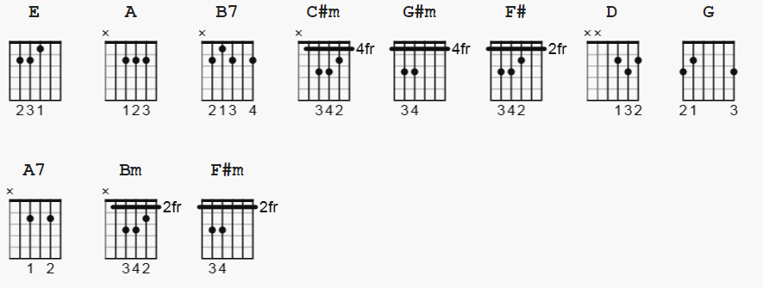

Basic strum: 1 2& 3 &4& with some changes TBD
D Du uDu

[Intro] TBD

E
When you're alone
A B7
And life is making you lonely,
E A B7
You can always go downtown
E
When you've got worries,
A B7
All the noise and the hurry
E A B7
Seems to help, I know, downtown

E C#m
Just listen to the music of the traffic in the city
E C#m
Linger on the sidewalk where the neon signs are pretty
G#m
How can you lose?
A
The lights are much brighter there
F#
You can forget all your troubles, forget all your cares and go

E A
Downtown, things'll be great when you're
E A
Downtown, no finer place for sure,
E A B7 E
Downtown, everything's waiting for you

E
Don't hang around
A B7
And let your problems surround you
E A B7
There are movie shows downtown
E
Maybe you know
A B7
Some little places to go to
E A B7
Where they never close downtown

E C#m
Just listen to the rhythm of a gentle bossanova
E C#m
You'll be dancing with 'em too before the night is over
G#m
Happy again
A
The lights are much brighter there
F#
You can forget all your troubles, forget all your cares and go

E A
Downtown where all the lights are bright,
E A
Downtown, waiting for you tonight,
E A B7 E
Downtown, you're gonna be alright now

E C#m
And you may find somebody kind to help and understand you
E C#m
Someone who is just like you and needs a gentle hand to
G#m
Guide them along
A
So, maybe I'll see you there
F#
We can forget all our troubles, forget all our cares and go

E A
Downtown, things'll be great when you're
E A
Downtown, don't wait a minute more,
E A B7 E
Downtown, everything's waiting for you

E B7 E B7 E B7 E B7
Downtown (downtown) downtown (downtown)

* Alternate:

Capo II

E = D
A = G
F# = E
B7 = A7
C#m = Bm
G#m = F#m

Video with chords and lyrics, key C with key change
to F#, C#, D#, G# etc...

https://www.youtube.com/watch?v=WgJAlj-QguA

