(The) End Of The World Skeeter Davis

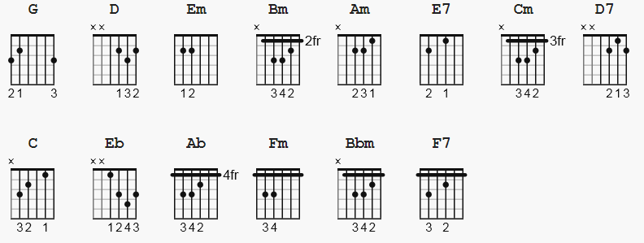

3/4 meter (CAPO 2 makes key A ) A good picking song; str 5 4 3 2 3 4. 5

[Intro]

G D Em D

[Verse 1]

G D
Why does the sun go on shining
Em Bm
Why does the sea rush to shore
Am Bm E7
Don't they know it's the end of the world
Am Cm D7 (should be C Am Cm D7 ??)
'Cause you don't love me anymore

[Verse 2]

G D
Why do the birds go on singing
Em Bm
Why do the stars glow above
Am Bm E7
Don't they know it's the end of the world
Am D7 G (should be C Am G D7 ??? )
It ended when I lost your love

[Verse 3]

C G
I wake up in the morning and I wonder
C D G ( C S/B Am ?? )
Why everything's the same as it was
Bm E7 (try E7 S/B Bm/E )
I can't understand, no I can't understand
Am Cm D7
How life goes on the way it does

[Verse 4]

G D
Why does my heart go on beating
Em Bm
Why do these eyes of mine cry
Am Bm E7
Don't they know it's the end of the world
Am D7 G
It ended when you said goodbye

Eb

[Verse 5]
(spoken)
Ab Eb
Why does my heart go on beating
Fm Cm
Why do these eyes of mine cry
(sung)
Bbm Cm F7
Don't they know it's the end of the world
Bbm Eb Ab
It ended when you said goodbye

[Outro]

Ab Cm Bbm Eb Ab

