Eve Of Destruction Barry McGuire Intermediate Level key D

As played by Barry McGuire. All lyrics with their accompanying chords, with all suspended chords and bass notes. Full chord legend included. https://www.youtube.com/watch?v=MdWGp3HQVjU

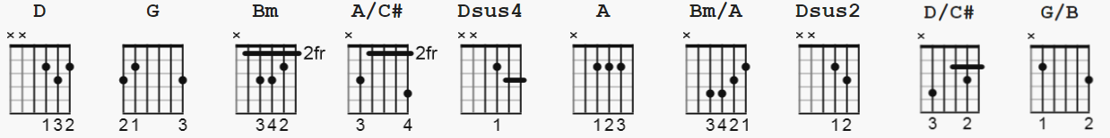

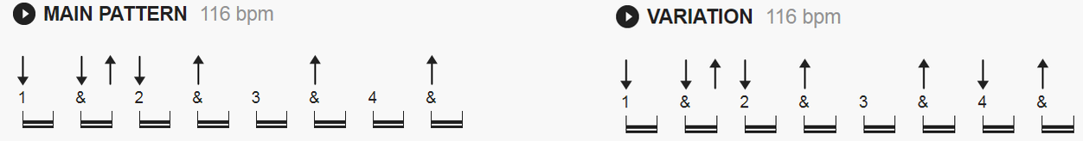

D = xx0232 G = 320033 Bm = x24432 (A/C#) = x42220
Dsus4 = xx0233 A = x02220 Bm/A = x04432
Dsus2 = xx0230 (D/C#) = x40232 (G/B) = x20033

-----------------------------------------------

[Intro]
D Dsus4 Dsus2 D Dsus4 Dsus2
||: / / / / | / / / / :|| [x2}

[Verse 1]
D G A
The Eastern world ...it is ex - ploding,
D Dsus4 Dsus2 G A
Violence flar - ing ...bullets loading,
D Dsus2 G A
You're old enough to kill, ...but not for voting,
D Dsus4 Dsus2 G A
You don't believe in war, ...but what's that gun you're toting?
D Dsus4 Dsus2 G A
And even the Jordan River has ...bodies floating

[Chorus]
D G A D (D/C#) Bm
But you ...tell me, over and over and over again my friend,
(Bm) (Bm/A) G
Ah, you don't believe...
(G/B) A (A/C#) D Dsus4 Dsus2
...We're on the eve of de - struction-------!

D Dsus4 Dsus2 G A
| / / / / | / / / / | / / / / |

[Verse 2]
D . G A
Don't you understand what I'm ...trying to say,
D G A
And can't you feel the fears I'm ...feeling to - day?
D Dsus4 Dsus2 G A
If the button is pushed ...there's no running a - way,
D Dsus4 Dsus2 G A
There'll be no one to save ...with the world in a grave,
D G A
Take a look around you, boy, it's bound to scare you boy

[Chorus]
D G A D (D/C#) Bm
And you ...tell me, over and over and over again my friend,
(Bm) (Bm/A) G (G/B) A
Ah, you don't believe ...we're on the eve...
(A/C#) D Dsus4 Dsus2 D Dsus4 Dsus2
...Of de - struction! Ummm------!

G A D Dsus4 Dsus2
| / / / / | / / / / | / / / / |

[Verse 3]
D Dsus4 Dsus2 D Dsus4 Dsus2 G A
Yeah, my blood's so mad ...feels like coagu - lating,
D Dsus4 Dsus2 G A
I'm sitting here just ...contem - plating,
D Dsus4 Dsus2 G A
I can't twist the truth ...it knows no regu - lation,
D Dsus4 Dsus2 G A
Handful of Sena - tors don't pass legis - lation,
D Dsus4 Dsus2 G A
And marches a - lone ....can't bring inte - gration,
D Dsus4 Dsus2 G A
When human res - pect is ...disinte - grating,
D Dsus4 Dsus2 G A
This whole crazy world ...is just too frust - rating

[Chorus]
D G A (A/C#) D (D/C#) Bm
And you ...tell me, over and over, and over again, my friend,
(Bm) (Bm/A) G (G/B) A
Ah, you don't believe ...we're on the eve...
(A/C#) D Dsus4 Dsus2 D Dsus4 Dsus2
...Of de - struction! Ummm, ummm!
G A
| / / / / | / / / / |

D Dsus4 Dsus2 D Dsus4 Dsus2
| / / / / | / / / / |

[Verse 4]
D Dsus4 Dsus2 G A
And think of all the hate ...there is in Red China,
D Dsus4 Dsus2 G A
Then take a look a - round ...to Selma, Ala - bama,
D Dsus4 Dsus2 G A
Eh, you may leave here ...for four days in space,
D Dsus4 Dsus2 G A
But when you re - turn, it's the same old place,
D Dsus4 Dsus2 G A
The pounding of the drums, the pride and dis - grace,
D Dsus4 Dsus2 G A
You can bury your dead, ...but don't leave a trace,
D G A
Hate your next door neighbour, but don't forget to say grace

[Chorus]
D G A
And you ...tell me, over and over,
D (D/C#) Bm
And over and over a - gain, my friend,
(Bm)(Bm/A) G
You don't believe...
(G/B) A (A/C#) D Dsus4 Dsus2
...We're on the eve of de - struction----,
D Dsus4 Dsus2 G
Umm, no, no, you don't believe...
G/B A (A/C#) D Dsus4 Dsus2
...We're on the eve of de - struction----!

[Coda]
D Dsus4 Dsus2 G D
| / / / / | / / / / | / ||

