Freight Train Elizabeth Cotton key C

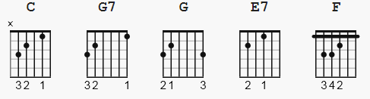 strum: Travis picking

[Intro] ( font 11 pt.)
?

C G7
Freight train, freight train, goin' so fast,
G C
freight train, freight train, goin' so fast
E7 F
Please don't tell what train I'm on,
C G7 C
so they won't know where I'm gone.

C G7
Freight train, freight train, goin' round the bend,
G C
freight train, freight train, comin' back again
E7 F
One of these days turn that train around,
C G7 C
and go back to my home town.

C G7
One more place I'd like to be,
G C
one more place I'd like to see
E7 F
To watch them old Blue Ridge Mountains climb,
C G7 C
when I ride old Number Nine.

C G7
When I die Lord, bury me deep,
G C
down at the end of Chestnut Street
E7 F
Where I can hear old Number Nine,
C G7 C
as she comes down the line.

C G7
Freight train, freight train, goin' so fast,
G C
freight train, freight train, goin' so fast
E7 F
Please don't tell what train I'm on,
C G7 C
so they won't know where I'm gone.

[outro] ???

