Friends In Low Places Garth Brooks

CAPO II key A ( finger G )

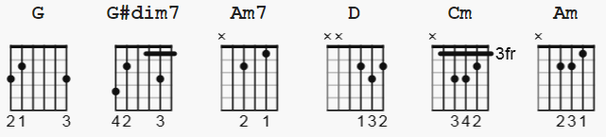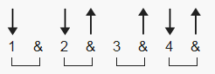

Abdim7 alternate; (G#dim7)= 456464 (barre 4) 108 bpm

[Intro]

G G#dim7 Am7 D
e|--------------|--------------|-----------3--|-------0h2-----|
B|-------0------|-------3------|-------1------|-----3---------|
G|-----0--------|-----4--------|-----0---0----|---2-----------|
D|---0----------|---3----------|---2----------|-0-------------|
A|--------------|--------------|-0------------|---------------|
E|-3------------|-4------------|--------------|---------------|

[Verse 1]

G
Blame it all on my roots
Abdim7
I showed up in boots
Am7
And ruined your black tie affair
D
The last one to know
D7
The last one to show
G
I was the last one you thought you'd see there
G
And I saw the surprise
Abdim7
And the fear in his eyes
Am7 Cm
When I took his glass of champagne
D
I toasted you
D D D
Said honey we may be through
D D
But you'll never hear me Complain

[Chorus]

G
'Cause I got friends in low places
G
Where the whiskey drowns and the beer chases
Am
My blues away
D
And I'll be okay
G
I'm not big on social graces
G G
Think I'll slip on down to the oasis
Am D
'Cause I've got friends
G
In low places

[Solo]

| G | G | G | G | Am | D | G | G |

[Verse 2]

G
Well, I guess I was wrong
Abdim7
I just don't belong
Am7
But then, I've been there before
D
Everything's alright
D
I'll just say goodnight
G
And I'll show myself to the door
G
Hey, I didn't mean
Abdim7
To cause a big scene
Am7 Cm
Just give me an hour and then
D
I'll be as high as that
D
Ivory tower
D D
That you're livin' in

[PLAY Chorus here]

[PLAY Chorus here]

[PLAY Chorus here AND FADE]

END***
/// POSSIBLE LYRICS TO ANOTHER VERSION LIVE??

[Verse 3]

G
I guess I was wrong
Abdim7
I just don't belong
Am7
But then, I've been there before
D
And everything's alright
D
I'll just say goodnight
G
And I'll show myself to the door
G
I didn't mean
Abdim7
To cause a big scene
Am7 Cm
Just wait 'til I finish this glass
D
Then sweet little lady
D
I'll head back to the bar
D
And you can
D
Kiss my ass!

[ PLAY Chorus here]

