Friends In Low Places Garth Brooks key A

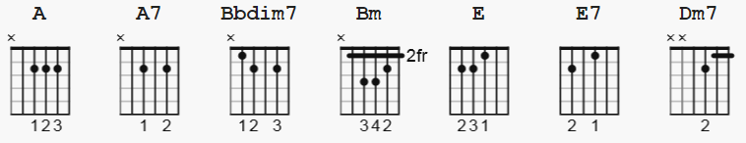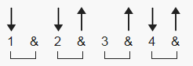

108 bpm barre Bbdim7= (bar 6) 678686; Dm7= x575565

[Intro]

A Bbdim7 Bm E
e|--------------|--------------|--------------|-----------0--|
B|-----------2--|-----------2--|-----------3--|--------------|
G|--------2-----|--------0-----|--------4-----|--------1-----|
D|-----2--------|-----2--------|-----4--------|-----2--------|
A|--0-----------|--1-----------|--2-----------|--------------|
E|--------------|--------------|--------------|--0-----------|

[Verse 1]

A
Blame it all on my roots
Bbdim7
I showed up in boots
Bm
And ruined your black tie affair
E
The last one to know
E7
The last one to show
A
I was the last one you thought you'd see there
A
And I saw the surprise
Bbdim7
And the fear in his eyes
Bm Dm7
When I took his glass of champagne
E
I toasted you
E7
Said honey we may be through
E E7
But you'll never hear me Complain

[Chorus]

A
'Cause I got friends in low places
A
Where the whiskey drowns and the beer chases
Bm
My blues away
E
And I'll be okay
A
I'm not big on social graces
A A7
Think I'll slip on down to the oasis
Bm E
'Cause I've got friends
A
In low places

[Verse 2]

A
Well, I guess I was wrong
Bbdim7
I just don't belong
Bm
But then, I've been there before
E
Everything's alright
E7
I'll just say goodnight
A
And I'll show myself to the door
A
Hey, I didn't mean
Bbdim7
To cause a big scene
Bm Dm7
Just give me an hour and then
E
I'll be as high as that
E7
Ivory tower
E E7
That you're livin' in

[PLAY Chorus here]

[Verse 3]

A
I guess I was wrong
Bbdim7
I just don't belong
Bm
But then, I've been there before
E
And everything's alright
E7
I'll just say goodnight
A
And I'll show myself to the door
A
I didn't mean
Bbdim7
To cause a big scene
Bm Dm7
Just wait 'til I finish this glass
E
Then sweet little lady
E7
I'll head back to the bar
E
And you can
E7
Kiss my ass!

[ PLAY Chorus here]

[end]

note: for E7 on "complain", use 4 finger E7

