Glory Days Bruce Springsteen

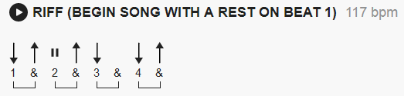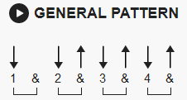

[Intro]

A D A D
e|-----------------|-------------------|-------------------|-----------------|
B|-----------------|-------------------|-------------------|-----------------|
G|-----------------|-2-2---2-4---2-----|-------------------|-2-2---2-4---2---|
D|-2---2-4---2-----|-0-0---0-0---0-----|-2-2---2-4---2-----|-0-0---0-0---0---|
A|-0---0-0---0-3h4-|---------------3p2-|-0-0---0-0---0-3h4-|-----------------|
E|-----------------|-------------------|-------------------|-----------------|

A D A D
e|-----------------|-----------------|-----------------|-----------------|
B|-----------------|-----------------|-----------------|-----------------|
G|-----------------|-2-2---2-4---2---|-----------------|-2-2---2-4---2---|
D|-2-2---2-4---2---|-0-0---0-0---0---|-2-2---2-4---2---|-0-0---0-0---0---|
A|-0-0---0-0---0---|-----------------|-0-0---0-0---0---|-----------------|
E|-----------------|-----------------|-----------------|-----------------|

[Verse]

A D A D
I had a friend was a big baseball player, back in high school
A D A D
He could throw that speedball by ya, make you look like a fool boy
E D
Saw him the other night at this roadside bar, I was walking in he was walking out
E D E
We went back inside, sat down, had a few drinks, but all we kept talking about

[Chorus]
A D
Glory Days, well they'll pass you by
A D
Glory Days, in the wink of a young girl's eye
A E A D
Glory Days, glory days

[Verse]
A D A D
There was a girl that lives up the block, back in school she could turn all the boys heads
A D A D
Sometimes on a Friday I'll stop by and have a few drinks, after she put her kids to bed

E D
Her and her husband Bobby, well they split up, I guess it's two years gone by
E D
We just sit around talking about the old times, she says when she feels like crying she starts
E
laughing thinking about

[Chorus]
A D
Glory Days, yeah they'll pass you by
A D
Glory Days, in the wink of a young girl's eye
A E A D
Glory Days, glory days

[Break]
E E D E

[Verse]
A D A D
Think I'm going down to the well tonight and I'm gonna, drink till I get my fill
A D A D
And I hope when I get older I don't sit around thinking about it, but I probably will
E D
Yeah just sitting back trying to recapture, a little of the glory of
E D E
Well the time slips away, and leaves you with nothing, mister, but boring stories of

[Chorus]
A D
Glory Days, yeah they'll pass you by
A D
Glory Days, in the wink of a young girl's eye
A E A
Glory Days, glory days
D
..., yeah they'll pass you by
A D
Glory Days, in the wink of a young girl's eye
A E A D
Glory Days, glory days

[Outro]
A D
All right Ooh yeah
A D
All right Come one now

Repeat and ad lib to end (15 total outro A D lines)

