Go All The Way Raspberries key C and A , et al

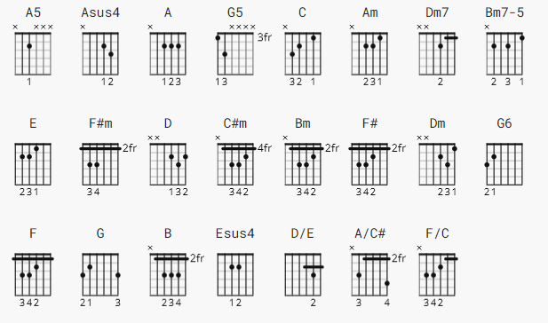

[Intro] (there are two guitars on the record, but when I saw the Raspberries
on TV, Wally Bryson combined both parts into one):

[Intro riff 1] [4X]

The easy way:
The authentic way (according to Raspberries biographer Ken Sharp,who learned it from Wally Bryson):

A5 Asus4 A A Asus4 A5 Asus4 A A Asus4
e|------------------------| |-12-10-9------9--10-10--|
B|-17-15-14-----14-15-15--| |-10-10-10-----10-10-10--|
G|-14-14-14-----14-14-14--| |-9--9--9------9--9--9---|
D|-14-14-14-----14-14-14--| |-7--7--7------7--7--7---|
A|-0----------------------| |-0----------------------|
E|------------------------| |------------------------|
[^ let ring (3rd, 4th time only)]

[Intro riff 2] [3X:]
A Asus4 [see above]
e|----------------------------------------|
B|------------------------14-15-15--------|
G|------2---2-------------14-14-14--------|
D|------2-4-2-4-----------14-14-14--------|
A|--3h4---------0-------------------------|
E|----------------------------------------|
[^ let ring]

G5
e|------------------|
B|------------------|
G|------2---2---0-0-|
D|------2-4-2---0-0-|
A|--3h4-------------|
E|--------------3-3-|
[Bass fill]
(C)
G|-----------------|
D|-5h7---5---------|
A|---------7-5-3---|
E|-----------------|

[Verse 1]
C Am Dm7
I never knew how complete life could be
/C Bm7-5 E
Til' she kissed me and said, baby

[Chorus]
A F#m D C#m Bm
Please (baby) go all the way
E C#m F#
It feels so right (feels so right)
Bm Dm E
Being with you here tonight
A F#m D C#m Bm
Please (baby) go all the way
E C#m F#
Just hold me close (hold me close)
Bm Dm [1: G6 2, 3: E]
Don't ever let me go
(don't let me go)

[Verse 2]
C Am Dm7
I couldn't say what I wanted to say
/C Bm7-5 E
'Til she whispered, "I love you" so

[Chorus]
A F#m D C#m Bm
Please (baby) go all the way
E C#m F#
It feels so right (feels so right)
Bm Dm E
Being with you here tonight
A F#m D C#m Bm
Please (baby) go all the way
E C#m F#
Just hold me close (hold me close)
Bm Dm [1: G6 2, 3: E]
Don't ever let me go
(don't let me go)

[repeat intro riff #1 (2X)]
[Bridge]
A Asus4 A Asus4 [A variants as per Riff 2]
Before her love I was cruel and mean
A F G A
I had a hole in the place where my heart should've been
A Asus4 A Asus4
Now I'm changed and it feels so strange
A F G A B
I come alive when she says all those things to me
E
And she says
A
(Come on) come on
E A
(Come on) come on
D
I need you (come on)
G
I love you (come on)
C Esus4 E
I need you (come on)

[Chorus]
A F#m D C#m Bm
Please (baby) go all the way
E C#m F#
It feels so right (feels so right)
Bm Dm E
Being with you here tonight
A F#m D C#m Bm
Please (baby) go all the way
E C#m F#
Just hold me close (hold me close)
Bm Dm [1: G6 2, 3: E]
Don't ever let me go
(don't let me go)

[Coda]
F#m(add9) F#m9/maj7 F#m9 F#m6 [arpeggiate on 12-string]
xx4224 xx3224 xx2224 xx1222
/ / / / / / / / / / / / / / / /
D/E A/C# F/C Bm E
xx0230
/ / / / / / / / / / / / / / / /

repeat [Intro Riff #1] (3X); end cold on A

