Good Riddance Time Of Your Life Green Day

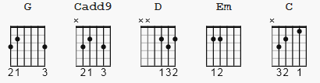

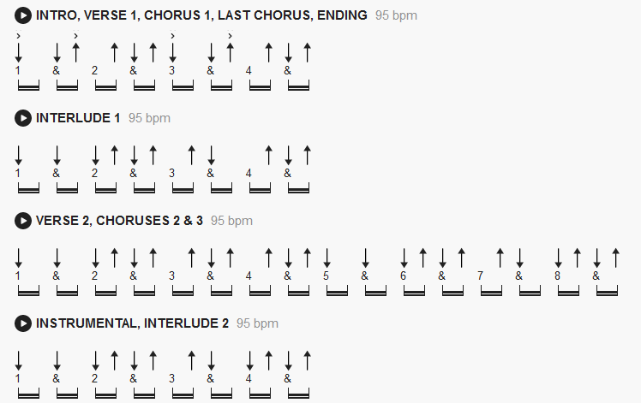

[Intro]

| G | G | Cadd9 | D |
| G | G | Cadd9 | D |

[Verse 1]

G Cadd9 D
Another turning point, a fork stuck in the road,
G Cadd9 D
Time grabs you by the wrist, directs you where to go
Em D C G
So make the best of this test and don't ask why
Em D C G
It's not a question but a lesson learned in time

[Chorus]

Em G Em G
It's something unpredictable but in the end it's right
Em D G
I hope you had the time of your life.

[Interlude]

| G | G | Cadd9 | D |
| G | G | Cadd9 | D |

[Verse 2]

G Cadd9 D
So take the photographs and still frames in your mind
G Cadd9 D
Hang it on a shelf, in good health and good time
Em D C G
Tattoos of memories and dead skin on trial
Em D C G
For what it's worth it was worth all the while

[Chorus]

Em G Em G
It's something unpredictable but in the end it's right
Em D G
I hope you had the time of your life.

[Instrumental]

| G | G | Cadd9 | D |
| G | G | Cadd9 | D |
| G | G | Cadd9 | D |
| G | G | Cadd9 | D |
| Em | D | C | G |
| Em | D | C | G |

[Chorus]

Em G Em G
It's something unpredictable but in the end it's right
Em D G
I hope you had the time of your life.

[Interlude]

| G | G | Cadd9 | D |
| G | G | Cadd9 | D |

[Chorus]

Em G Em G
It's something unpredictable but in the end it's right
Em D G
I hope you had the time of your life.

[Outro]

| G | G | Cadd9 | D |
| G | G | Cadd9 | D |
| G |

