Grandma Got Gun Gver By a Reindeer key E

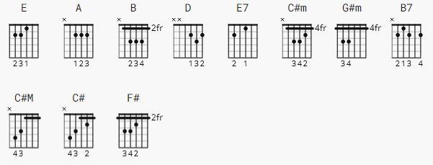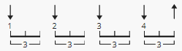
200 bpm
[Intro 1]

e|------3-3-3---3-3-3--3-7-----4-|--------|
B|------5-5-5---5-5-5--5---5-7-5-|--------|
G|-------------------------------|--------|
D|-------------------------------|------1-|
A|-------------------------------|--2-4---|
E|-------------------------------|--------|

[Intro 2]

E

[Chorus]

E
Grandma got run over by a reindeer
A
Walking home from our house Christmas eve
E
You can say there's no such thing as Santa
B E D A E
But as for me and Grandpa, we believe

[Verse]

E B
She'd been drinkin' too much egg nog
E
And we begged her not to go
E7 A
But she forgot her medication
B E C#m
And she staggered out the door into the snow
G#m B7
When they found her Christmas morning
E E7
At the scene of the attack
A
She had hoof prints on her forehead
B E
And incriminating Claus marks on her back

[Chorus]

E
Grandma got run over by a reindeer
A
Walking home from our house Christmas eve
E
You can say there's no such thing as Santa
B E D A E
But as for me and Grandpa, we believe

[Verse]

E B
Now were all so proud of Grandpa
E
He's been takin' this so well
E7 A
See him in there watching football
B E C#m
Drinking beer and playing cards with cousin Mel

G#m B7
It's not Christmas without Grandma
E E7
All the family's dressed in black
A
And we just can't help but wonder
B E
Should we open up her gifts or send them back? (SEND THEM BACK???)
[Chorus]

E
Grandma got run over by a reindeer
A
Walking home from our house Christmas eve
E
You can say there's no such thing as Santa
B E D A E
But as for me and Grandpa, we believe

[Verse]

E B
Now the goose is on the table
E
And the pudding made of fig
E7 A
And a blue and silver candles
B E C#m
That would just have matched the hair in Grandma's wig
G#m B7
I've warned all my friends and neighbors
E E7
Better watch out for yourselves
A
They should never give a license
B E C#
To a man who drives a sleigh and plays with elves

[Ending]

F#
Grandma got run over by a reindeer
B
Walking home from our house Christmas eve
F#
You can say there's no such thing as Santa
C# F# C# F#
But as for me and Grandpa, we be-li-e-eve! (Merry Christmas!)

