Green River Creedence Clearwater Revival

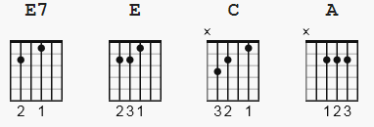

NOTE: this is the simple chording version. More popular is the TABS
which can be found on ultimate-guitar.com because of the distinctive sound.

one basic strum type: D D Du Du

[Intro]

E7

[Verse 1]

E
Well take me back down where cool water flows yeah.
E
Let me remember things I love
E
Stoppin at the log where catfish bite
C
Walkin along the river road at night
A E7
Barefoot girls dancin in the moonlight

[Verse 2]

E
I can hear the bullfrog callin me.
E
Wonder if my ropes still hangin to the tree.
E
Love to kick my feet way down the shallow water.
C
Shoofly, dragonfly, get back to mother.
A E7 C A E
Pick up a flat rock, skip it across green river.

[ Solo Instrumental ]

[Verse 3]

E
Up at codys camp I spent my days, oh,
E
With flat car riders and cross-tie walkers
E
Old cody junior took me over,
C
Said, youre gonna find the world is smouldrin.
A E7
And if you get lost come on home to green river. **END**

