Handle On You Parker McCollum key D

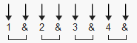 104 bpm

Capo 4th fret. Em7= 02x030
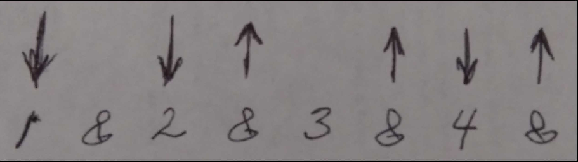

If you don't want to use a capo transpose +4 steps.

[Intro]
D A Em G D A Em

[Verse 1]
D A Em7 G
I went and got the biggest bottle they got 'cause you're gone
D A Em7 G
Drop a needle on a vinyl and cry to old an Haggard song
D A
Sittin' at the table, baby breakin' the seal
Em7 G
Gonna see how much of this pain I can kill
D A Em7 G
I went and bought the biggest bottle they got 'cause you're gone

[Chorus]
D
Tennessee and Kentucky
A
'Cause you ain't here to love me
Em7 G
I drink now that there's nothing to lose
D
I been fightin' with your memory
A
I hate the way it hits me
Em7 G
I wake up everyday black and blue
Bm A G
After all this back and forth, a fifth won't do
Em7 G D A Em7
Yeah I finally got a handle, finally got a handle on you
[Verse 2]
D A Em7 G
I tell myself that I should quit but I don't listen to drunks
D A Em7 G
I keep on sippin' 'til "I miss you" don't roll off my tongue
D A
Since you poured our love down the sink
Em7 G
I think I'll just stay here and drink
D A Em7 G
I tell myself that I should quit but I don't listen to drunks

[Chorus]
D
Tennessee and Kentucky
A
'Cause you ain't here to love me
Em7 G
I drink now that there's nothing to lose
D
I been fightin' with your memory
A
I hate the way it hits me
Em7 G
I wake up everyday black and blue
Bm A G
After all this back and forth, a fifth won't do
Em7 D
Well, I finally got a handle on you

[Guitar Solo]
D A Em7 D A Em7

[Outro]
Bm A G
After all this back and forth, a fifth won't do
Em7 A D
Yeah, I finally got a handle, finally got a handle on you
A Em
Handle on you
D A Em
Yeah, I finally got a handle on you

